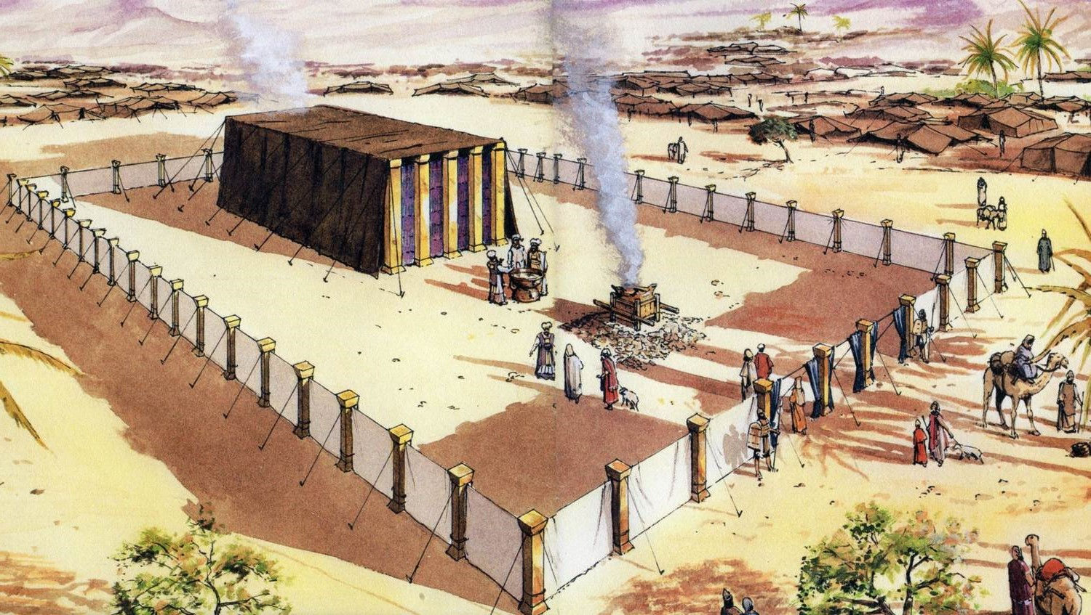

Contents
INTRODUCTION 2
PART 1 - THE PLAN 3
PART 2 - THE OUTER COURT 5
PART 3 - THE BRASEN ALTAR 6
PART 4 - THE LAVER 8
PART 5 - THE TABERNACLE STRUCTURE 10
PART 6 - THE TABLE OF SHEWBREAD 12
PART 7: THE GOLDEN CANDLESTICK 14
PART 8: THE GOLDEN ALTAR 16
PART 9: THE MOST HOLY PLACE 18
PART 10: THE ARK OF THE COVENANT 20
PART 11: THE MERCY SEAT 22
FURTHER INFORMATION 24

INTRODUCTION

These outline notes on the ‘Teaching of the Tabernacle in the Wilderness’, were originally compiled by my father, the Rev L G Stapleton, many years ago, and used in week-night Bible Studies together with painted illustrations. They are now presented as Bible Study Notes. Only one photo copy of one of the original pictures remains - it is now used in PART 5 of the notes – showing the Tabernacle Structure. Other illustrations have been taken from Colour Plates from a book - ‘Christ In The Tabernacle’ (1877) by Frank H White. The front cover picture is taken from the CANDLE BOOKS – ‘Essential Bible Reference Series – ‘The Tabernacle’ by Tim Dowley (permission applied for).

Compiled and Edited by Mark Stapleton

© Mark Stapleton
August 2026

Note –
- The measurements given in these notes are based on a cubit (measured from the elbow to the tip of the index finger) which is approx. equal to ½ metre (50 cm).
- In these notes, the word BRASS (BRASEN) has been used as in the KJV. The equivalent in the NKJV is BRONZE.
- The ‘CONTENTS’ page list is linked to the chapter headings. Use ‘CONTROL+ mouse click.

Scripture refences and quotes are based on the King James Version (KJV).

A series of PowerPoint presentations on ‘The Teaching of the Tabernacle in the Wilderness, is also available. It can be viewed at this WebSite =

https://www.oneagleswings.me.uk/grandpastabernacle/

PART 1 - THE PLAN

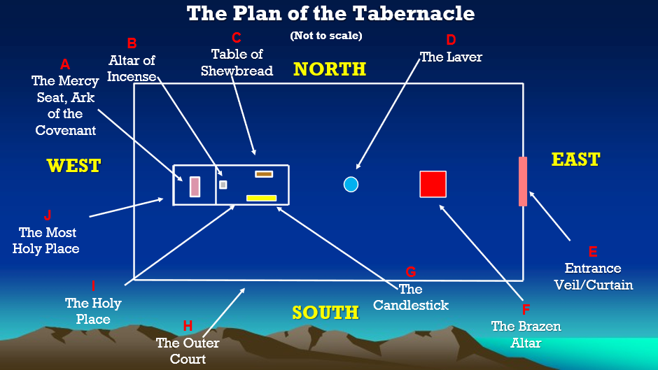

- The Mercy Seat and the Ark of the Covenant (Exodus 25: 10-22).
- The Altar of Incense (Exodus 30: 1-10).
- The Table of Shewbread (Exodus 25: 23-30.
- The Laver (Exodus 30: 17-21).
- Entrance veil/curtain (Exodus 27: 16-19).
- The Brasen Altar or Altar of burnt Offering (Exodus 27: 1-8).
- The Golden Candlestick (Exodus 25: 31-40).
- The outer court (Exodus 27: 9-15).
- The Holy Place (Exodus 26: 1-36).
- The Most Holy Place (Exodus 26: 1-36).

THE SIGNIFICANCE OF THE COLOURS (As usually accepted)

GOLD - The Divine Glory
RED - Sacrifice
BLUE - The Heavenly
PURPLE - Royalty & Priesthood

THE SIGNIFICANCE OF THE MATERIALS

SILVER - Redemption
BRASS - Sin judged
WHITE LINEN - Righteousness
ACACIA WOOD - Holy manhood
OIL - The Holy Spirit

- THE PATTERN OF THE TABERNACLE
1. Given in detail - Exodus Chapters 25-31.
2. Carried out in detail - Exodus Chapters 35-40.

(N.B. Exodus 25: 9; 25: 40; 39: 43 and Hebrews 8: 5)

The AUTHORITY for using the Tabernacle for SPIRITUAL lessons: Hebrews 8:5; 9: 8; 11: 23-26; 10:19-22.

- THE PURPOSE OF THE TABERNACLE

1. It represented God's PRESENCE (Exodus 25: 8).
2. It was GOD'S MEETING PLACE with His people (Exodus 25: 22).

- THE POSITION OF THE TABERNACLE

1. In the CENTRE of the Camp.
2. Each tribe had its allotted place around it (Numbers chapters 2 & 3).

- THE PLAN OF THE TABERNACLE

1. The Outer Enclosure - 100 cubits x 50 cubits (50 x 25 metres) Exodus 27: 9-19.
2. The Tabernacle proper - 30 cubits x 10 cubits (15 x 5 metres) divided into: -
a. The HOLY PLACE – 20 cubits x 10 cubits (10 x 5 metres) Exodus chapter 26.
b. THE HOLY OF HOLIES – 10 cubits square (5 x 5 metres) Exodus chapter 26.

N.B. Approx. measurements

- THE PRIESTLY SERVICE OF THE TABERNACLE

1. The Courtyard work - dismantling, carting and carrying and re-erecting - THE TRIBE OF LEVI.
2. The HOLY PLACE - the priests (sons of Aaron/Tribe of Levi).
3. The HOLY OF HOLIES - the high priest (Aaron/Tribe of Levi).

- THE PROGRESSIVE TEACHING OF THE TABERNACLE

- It all speaks to the believer of the LORD JESUS CHRIST.
- Details are given in the Bible as from God outwards.
- We enter in SPIRITUALLY in the opposite direction.

PART 2 - THE OUTER COURT

Exodus 27: 9-15, 38: 9-17

Bounded by A FENCE OF CURTAINS (see key – Part 1 – THE PLAN – H)

- THE CURTAINS

- Fine twined linen (Exodus 27: 9 and Revelation 19:8).
- It formed a barrier (God demands righteousness).
- Too high to see over (John 3: 3,5).

All are excluded (Luke10: 25,28 and Romans 3: 19-20).

CHRIST IS OUR RIGHTEOUSNESS (Romans 10: 3,4).

- THE POSTS (To support the curtains)

- Made of shittim wood (Acacia - margin) (see key – Part 1 = Earthly – Holy Manhood).
- Set in Brass Sockets (Exodus 27: 10). (see key – Part 1 = Sin judged).
- Capped with Silver (see key – Part 1 = Redemption).

Christ condemns all unrighteousness and upholds the righteousness of God.

- THE WAY IN

East end only - Exodus 27: 16. See PART 1 – THE PLAN = E.

- The Door - A veil or curtain, suspended on four posts, made of fine linen, coloured red, purple and blue.
- a. Easily seen. b. Open to all. c. Only way in.
- CHRIST SAID – ‘I am the door' - John 10: 9.
- We may enter in – John 14: 6.

PART 3 - THE BRASEN ALTAR

Exodus 27: 1-8, 38: 1-7 (see PART 1 – THE PLAN – F)

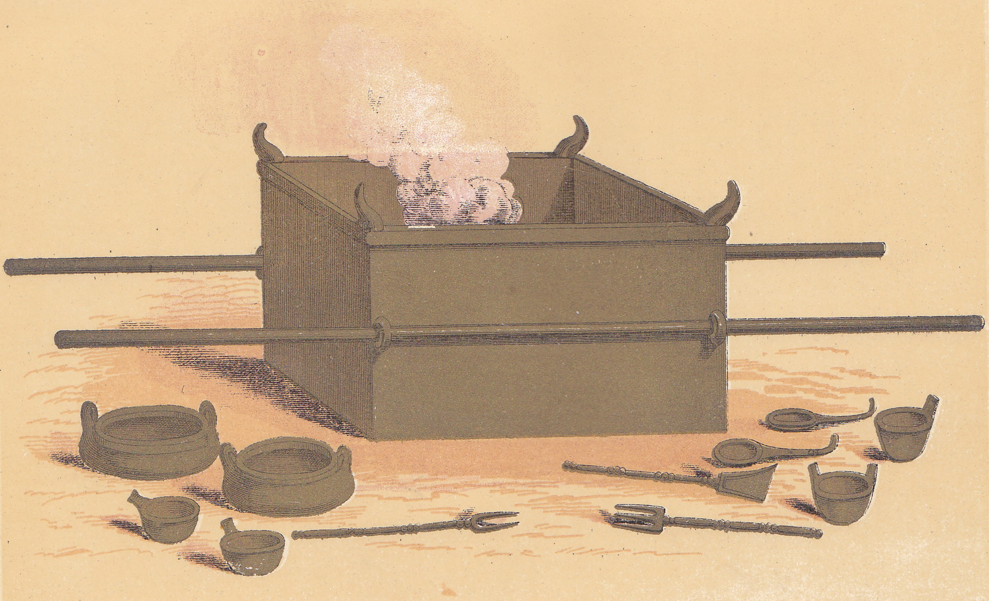

- THE POSITION
  - In the outer court. -East end.
  - The first thing a person met (by the gate -veil).

- THE PURPOSE
  - Simply for the offering of sacrifices.
  - The only place in the whole tabernacle where sacrifice was made or allowed.

- THE DETAILS – 5 cubits square x 3 cubits (approx. 2½ metres x 1½ metres)
  - A hollow square of shittim wood boards (acacia - margin) (overlaid with brass – Exodus 27: 8).
  - A ledge round (Exodus 27: 5-6 - R.V.).
  - Four horns (shittim wood, overlaid with brass – Exodus 27: 2).

- THE INSTRUMENTS
  - Pans, shovels, basins, flesh hooks etc. (all of Brass – Exodus 27: 3).
  - Two staves for carrying (shittim wood, overlaid with Brass – Exodus 27: 6).
Note: The whole altar and its accessories showed nothing but Brass.

- THE HORNS
  - On all four corners (Exodus 27: 2, 38: 2).
  - Symbolic of power (Deuteronomy 33: 17; 1 Kings 22: 11; Jeremiah 48: 25).
Note also - 1 Kings 1: 50,51; 1 Kings 2: 28; Amos 3: 14.

- THE MEANING (Brasen Altar represents the cross of Calvary)
  - Open to the sinner.
  - Sacrifice essential in approaching God (Hebrews 9: 22; 10: 4,12).
  - Shows divine judgment on sin (2 Corinthians 5: 21).
  - Fire never went out (Leviticus 6: 13).

- THE SACRIFICE
  - Various animals for various cases (Leviticus chapters 1-6).
  - Five main offerings: -
- Three sweet savour offerings (Leviticus chapters 1-3).
- Two non-sweet savour offerings (Leviticus chapters 4-5).

"WITHOUT THE SHEDDING OF BLOOD IS NO REMISSION" HEBREWS 9: 22

PART 4 - THE LAVER

Exodus 30: 18-21, 38: 8 (see PART 1 – THE PLAN – D)

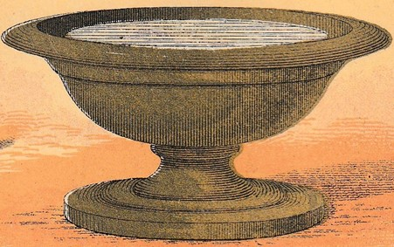

- THE POSITION

  - In the outer court.
  - Between the Brasen altar and the tabernacle proper (Exodus 30: 18).

- THE MATERIALS

  - All brass (From the women's mirrors – Exodus 38: 8; James 1: 23).
  - No size or shape given.
  - Held water.

- THE PURPOSE

  - For washing hands and feet (Exodus 30: 21).
  - Only for the priests (Exodus 30: 19). Note - not for all the Levites.
  - Preparation for service and worship.
  - Penalty for not using it was death (Exodus 30: 20).

- THE SIGNIFICANCE

  - Used before coming to the Brasen altar (outward service).
  - Used before going into the tabernacle (inward worship).
  - Brasen altar showed sin dealt with as by a judge.
  - Laver shows offences dealt with as by a father.

- THE MEANING

- All believers are priests (1 Peter 2: 5, 9; Revelation 1: 6; 5: 10).
- Constant need of washing - the Water of the Word (Ephesians 5:26; John 15:3).
- We are cleansed from the guilt of sin at the Brasen altar.
- We are cleansed from the defilement of sin daily at the laver (John 13: 10).

Note: Psalm 24: 3-5 (Apply it re worship and service)
Psalm 119:9 (The need for daily Bible reading)

PART 5 - THE TABERNACLE STRUCTURE

Exodus 26: 1-30; 36: 8-38 (see PART 1 – THE PLAN – I, J)

Note: in our Authorised Version there is no consistent translation of the words for 'tent' and 'tabernacle'.

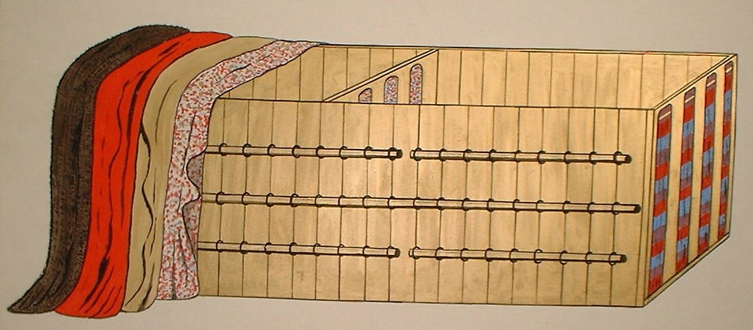

- GENERAL DESCRIPTION
  - Overall size: 30 cubits x 10 cubits x 10 cubits (15 x 5 x 5 metres – approx.) (Exodus 36: 21-27).
  - Of hollow rectangular shape, made of coupled boards.
  - Covered with four curtains.
  - Divided into two compartments (see PART 1 – THE PLAN – I, J).

- THE BOARDS (Exodus 26:15-29; 36: 20-34).
  - Each 10 cubits x 1¹/₂ cubits (5 metres high by ¾ metre wide) - no thickness given.
  - Shittim wood (acacia - margin) covered with gold (see PART 1 – THE PLAN) (Exodus 26: 15).
  - Two tenons at the base of each to fit into sockets (Exodus 26: 17,19).
  - Bars along the sides, slotting into rings of gold (Exodus 26: 29).

- THE SOCKETS (Exodus 26: 19-25; 38: 26).
  - Made of silver = redemption money (Exodus 38: 25-27).
  - 100 in number – each of 1 talent = approx. 45 kilos (Exodus 38: 27).
  - Note -sockets to the five pillars at the entrance were of brass.

- THE COVERINGS
  - The order in Exodus 26 is from God outwards (See PART 1 – THE PLAN – f. 2. – ‘The Progressive Teaching of the Tabernacle’).

    - Badger skins (or seal skins?) - only things visible outside (Isaiah 53: 2,3) (Exodus 26: 14).
    - Ram skins dyed red = substitution (Exodus 26: 14; Hebrews 9: 22).
    - Goats’ hair - covers the tabernacle proper (Exodus 26: 7).
    - Linen (Exodus 26: 1-6). This is the tabernacle proper.
Coloured red, blue and purple, with cherubim, formed the ceiling inside.
Loops of blue and hooks of gold (Exodus 26: 4,6).
Visible only within (1 Corinthians 2: 10,14).

- THE VAILS
  - The outer vail (Exodus 26: 36-37) –
Blue, red and purple; sockets of brass.
5 pillars of shittim wood (acacia - margin) overlaid with gold.

  - The inner vail (Exodus 26: 31-33)
Blue, red and purple, plus the cherubim.
4 pillars of shittim wood, overlaid with gold.
Sockets of silver.

PART 6 - THE TABLE OF SHEWBREAD

Exodus 25:23-30; 37: 10-16 see PART 1 – THE PLAN – C)

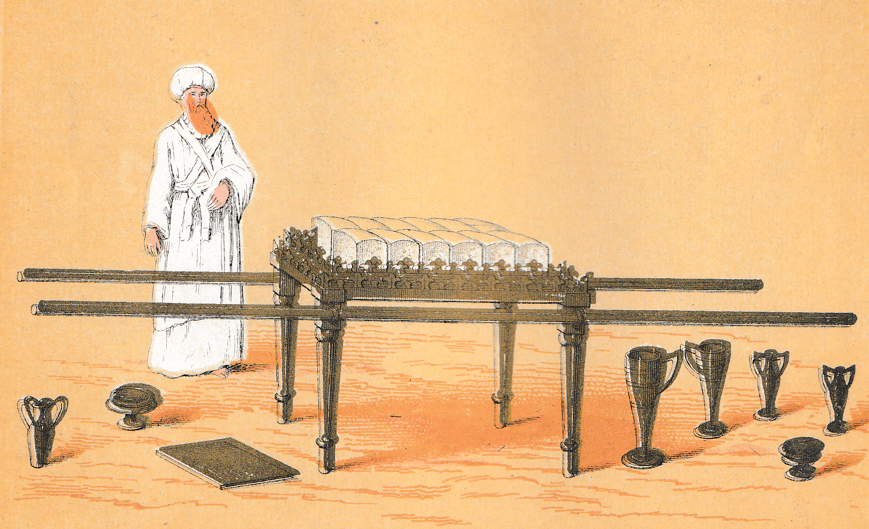

- THE DETAILS
  - Made of shittim wood (acacia - margin), overlaid with gold (Exodus 25: 23,24).
  - The size was 1 metre x ½ metre x ¾ metre – approx. (2 cubits x 1 cubit x 1¹/₂ cubit).
  - Ornamented with a crowning piece and a border of some kind.
  - Four golden rings to take the two carrying staves; the staves were of shittim wood (acacia - margin), overlaid with gold (Exodus 25: 26-27).
  - Detailed instructions given for packing (Numbers 4: 7,8). It was to be carried by the Kohathites (Numbers 4: 15).

- THE VESSELS
  - Dishes, bowls, spoons, covers, jugs.
  - All these were of gold (No more brass - sin judged is not to be reflected upon continually).

- THE POSITION AND PURPOSE
  - In the holy place (Accessible only to the priests).
  - On the north side, before reaching the inner veil (Exodus 40: 22).
  - The table was merely to hold the shewbread and it is to this bread that we must look for the significance of the table.

- THE SHEWBREAD (Leviticus 24: 5-9) – Literally - bread of the presence.
  - Consisted of twelve loaves or cakes.
  - Made of fine flour - no leaven - baked with fire - verse 7.
  - Arranged in two rows of six (A.V.) but more likely in two piles of six Leviticus 24: 6.
  - Frankincense was put on each pile – Leviticus 24: 7 (This was not incense although it formed one of the ingredients of incense (Exodus chapter 30 verse 34).
  - Bread was changed each Sabbath day – Leviticus 24: 8. That which was taken away was eaten by Aaron and his sons – Leviticus 24: 9.

THE TEACHING
- John 6: 35 gives us the key. Jesus is the bread of life to the believer priest.
- We need to appropriate Him as the sinless one (lack of leaven), and as the positively righteous one (fine flour).
- We are to feed upon Him for the maintenance of spiritual life (This can only be done in the holy place).

Note: John 6:33, 35,48

PART 7: THE GOLDEN CANDLESTICK

Exodus 25: 31-40; 37: 17-24 (see PART 1 – THE PLAN – G)

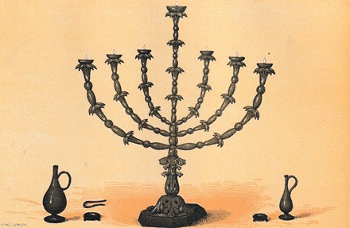

- THE DETAILS

- No size given.
- Entirely of beaten gold (Exodus 25:36 - cf. the laver - brass).
- Made of one talent of gold (Exodus 25: 39) = approx. 45 kilos (current value not known).
- Consisted of the main shaft, with six branches in pairs, making a total of seven lamps (Exodus 25: 37).
- Various ornamental work on each branch (Exodus 25: 33-36).

- THE INSTRUMENTS

  - Snuffers, tongs and vessels (Exodus 25:38).
  - All of gold.

- THE POSITION

In the holy place, on the south side, opposite the table of shewbread (Exodus 40: 24).

- THE FUEL

  - The purest olive oil (Beaten olives).
  - Continual supply required (Exodus 27: 20,21; Leviticus 24: 1-4).
  - Trimmed and lit by the high priest (Aaron) (Exodus 30: 7,8).

- THE PURPOSE

To give light in the holy place (Exodus 25: 37).

- THE MEANING

- All gold = wholly divine. Attended to only by the high Priest.
- It was beaten into shape (Isaiah 53: 10; Hebrews 2: 10). Note: The last blow made it perfect.
- Oil = Holy Spirit. Result of crushing olives.
- The Glory of God is revealed in the Holy Place by the Holy Spirit through Christ.
- Christ is the Light of the World (John 9: 5).

PART 8: THE GOLDEN ALTAR

Exodus 30: 1-10; 37: 25-28 (see PART 1 – THE PLAN – B)

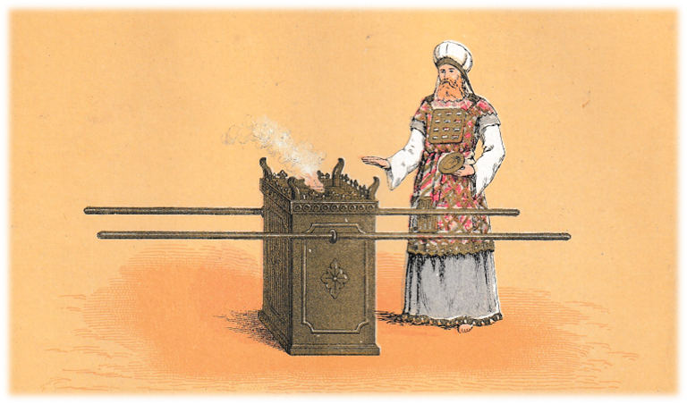

- THE DESCRIPTION (Exodus 30: 2,3)

  - Made of shittim wood (acacia - margin), overlaid with gold.
  - Dimensions – Approx.1 cubit square by 2 cubits high (Approx. ½ metre square, by 1 metre high).
  - Decorated with a golden crown. Fitted with golden rings, into which fitted two staves for carrying (shittim wood, covered with gold).
  - Also referred to as the altar of incense.
  - A golden censer was used in conjunction with it.

- THE POSITION

In the holy place, near the vail that led to the Holy of Holies (Exodus 30: 6).

- THE PURPOSE

For the burning of incense – NOT for sacrifice (see PART 3).

- THE INCENSE

  - To be burned continually (Exodus 30: 7-9).
  - To be made specially for God (Exodus 30: 34-38).
  - It was a perfume, only used in worship.
  - It was only to be burnt by the priests (Numbers 16: 39-40; 2 Chronicle 26:16-18).
  - No other incense was to be offered to God (Exodus 30: 9).

- THE SIGNIFICANCE OF THE INCENSE

  - It signified prayer in worship, and worship in prayer (Psalm 141: 2).
  - Used in approaching the mercy seat (Leviticus 16: 12).

- THE SIGNIFICANCE OF THE GOLDEN ALTAR

  - Linked with the brasen altar (Leviticus 4: 7).
  - Linked with the daily burnt offerings (Exodus 29: 39,42; 30:7-8).
  - Linked with the golden candlestick (Exodus 30: 7,8).
  - Sacrifice ascending without -prayer ascending within.
  - The only basis of prayer is the atonement. The atonement is made effective by prayer.

He ever lives to make intercession for us – Hebrews 7: 25

PART 9: THE MOST HOLY PLACE

Exodus 26: 31-35; 36: 35-36 (see also PART 1 – THE PLAN – J)

The most -----------The Holy Place -----------
Holy Place
Vail No. 2 Vail No. 1

The Ark of the covenant & the Mercy seat. The Altar of Incense. The Table of Shewbread.

The Golden Candlestick.

- THE NAMES
  - The most Holy Pace (Exodus 26: 33).
  - The Holiest of All (Hebrews 9: 8; 10: 19).
  - The Holy of Holies (Greek word –Hebrews 9: 3).
  - Sometimes referred to as the Holy Place (Leviticus 16: 2).

- THE CONTENTS (see also PART 10)
  - The ark of the covenant.
  - The mercy seat.
  - The cherubim over the mercy seat.

- THE ENTRANCE
  - Through the vail (No.2. in above plan -see Exodus 26: 33).
  - The vail was made of fine linen -blue, scarlet and purple (see also PART 1).
  - Embroidered with cherubim (different from veil No.1).
  - Suspended on golden hooks (Exodus 26: 32).
  - Four pillars of shittim (acacia - margin) wood, overlaid with gold (Exodus 26: 32).
  - Pillars stood in silver sockets (Exodus 26: 32. See also PART 1).
  - The vail acted as a barrier and as a way of access.

- THE CONDITIONS OF ENTRY
- On one day only (Leviticus 16 and Hebrews 9: 7).
- By one man only (Hebrews 9: 7).
- With one requirement - the blood of the sin offering (Leviticus 16: 3,14; Hebrews 9: 7).
- For one reason (Hebrews 9: 12).

- THE APPLICATON TO THE LORD JESUS CHRIST
  - The one day (Matthew 27: 51; Hebrews 9: 12).
  - The one Man (Hebrews 10: 12).
  - The one condition (Hebrews 9: 12).

- THE RESULT FOR THE BELIEVER-PRIEST
- The vail has been rent (Matthew 27: 51; Hebrews 10: 20; Romans 5: 2).
- We may enter into the holiest of all (Hebrews 10: 19).
- We do so cleansed (Brasen altar) and washed. (Laver – Hebrews 10: 22).
- Christ entered to complete Salvation, by intercession etc.
- We enter to worship as well as to intercede (Hebrews 4: 16).

PART 10: THE ARK OF THE COVENANT

Exodus 25: 10-16; 37: 1-8 (see also PART 1 – THE PLAN – A)

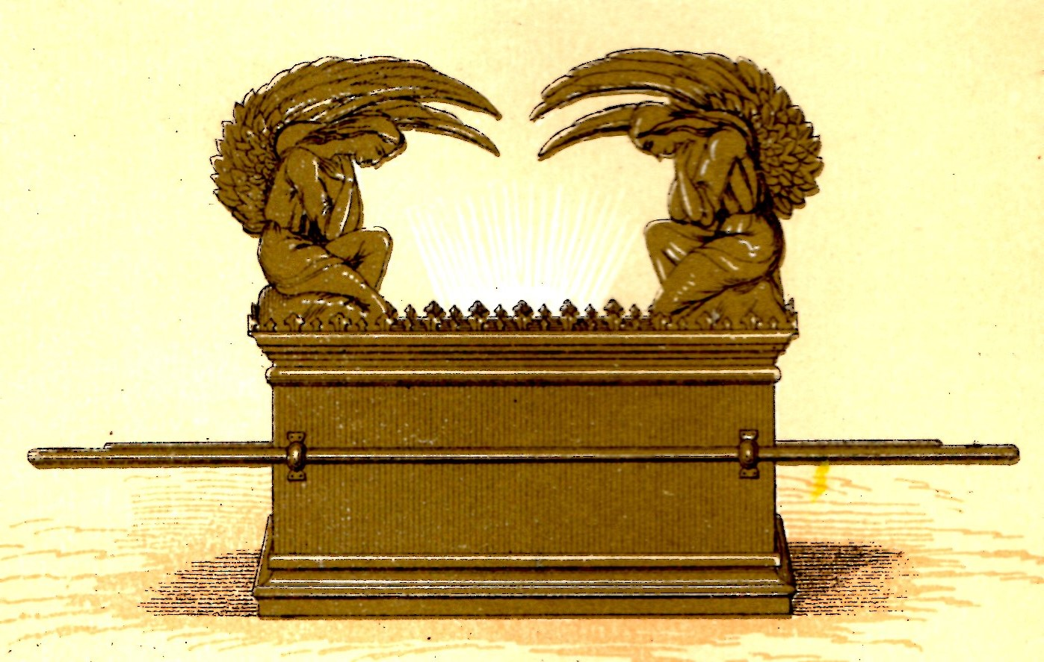

- THE STRUCTURE
- Shittim wood (acacia – margin), overlaid with gold, inside and out (Exodus 25: 11).
- 2½ cubits x 1½ cubits x I½ cubits (1¼ metres x ¾ metre x ¾ metre – approx.).
- A crown of gold. Four golden rings.
- Two staves of shittim wood (acacia – margin), overlaid with gold (N.B. Exodus 25: 15).

- THE POSITION
In the Holy of Holies -surmounted by the Mercy Seat and cherubim.

- THE PURPOSE
  - The preservation of the contents (cf. Moses – hidden in an ark of bulrushes, and Noah – 8 persons preserved in the ark.
  - As a base of the mercy seat. Basis of worship.
  - Essentially the Ark of the Covenant – between God and His people.

- THE CONTENTS (Hebrews 9: 4)
  - The tables of the law/covenant (Exodus 32: 15,19; 34: 28,29).
  - = A reminder of God's holiness – God’s Law in us (Psalm 40: 8 - seen in Christ).
  - Pot of manna (Exodus 16: 32,34). Now incorruptible – seen in Christ.
  - = A reminder of God's faithfulness in supplying Israel’s need (John 6: 32-36 - seen in Christ).
  - Aaron's rod that budded (Numbers 16: 5; 17: 2,5).
  - = A reminder of God's seal on his chosen leaders.
  - The resurrection seals Christ as God's choice - our great High Priest (Hebrews 7: 28).
- THE GUARANTEE.

Our acceptance in worship -the basis is Christ and the New Covenant that is ours in him (Luke 22: 20).

PART 11: THE MERCY SEAT

Exodus 25: 17-22; 37: 6-9 (see also PART 1 – THE PLAN – A)

- THE DESCRIPTION

  - Made of pure gold (Exodus 25: 17).
  - 2½ cubits x l½ cubits x ? (1¼ metres ¾ metre - no height given).
  - Surmounted by two cherubim of pure beaten gold (verse18). One each end facing inwards, with wings over the mercy seat (verse 20).

- THE POSITION

  - The mercy seat stood upon the ark of' the covenant, of which it formed the lid (Exodus 25: 21).
  - It was therefore in the Holy of Holies (see PART 9).

- ITS USE

  - Once a year on the Day of Atonement (Leviticus 16: 14, 30).
  - Blood of the sin offering sprinkled upon it (Leviticus 16: 14). Link with the Brasen altar – PART 3.
  - As a lid or covering for the ark of the covenant (Hebrew word = ‘kaporet’).

- ITS MEANING

  - Sin is covered, in the O.T., on the ground of an offering made and the blood presented (Hebrews 9: 12, 28; 10: 4).
  - This in turn is based on the covenant (agreement) God has made (PART 10).

- THE NEW TESTAMENT COUNTERPART

  - The N.T. knows nothing of atonement in the O.T. sense. Sin is now not covered but put away.
  - The Mercy-Seat (Hebrews 9: 5) is known as the propitiatory in the N.T. i.e. the place of receiving favour, forgiveness.
  - The right word in the N.T. is reconciliation = man's approach on God’s terms (i.e. a dealing with sin first).
  - This is made possible by the act of propitiation (Christ turned away God’s anger from the sinner by taking it Himself - 1 John 2: 2, Hebrews 8: 1, 10: 12-15).
  - The Mercy seat = the throne of grace (Hebrews 4: 16). There, God communes with us (Exodus 25: 22).

FURTHER INFORMATION

For further information, or to get in touch, please use the contact form on —
www.oneagleswings.me.uk

