BIBLE HELPS

THE TEN COMMANDMENTS

The Ten Commandments – Exodus 20: 1-17

The Ten Commandments were given to Moses, the God-appointed leader of the people of Israel, when they stopped on their journey from Egypt to the promised land of Canaan. at Mount Sinai. This Mount Sinai is in a mountainous area in the southern part of the Sinai Peninsula, between the Gulf of Aqaba and the Gulf of Suez (see map below). God had instructed Moses to gather the people of Israel at the foot of Mount Sinai, where He addressed the people and gave them the Ten Commandments (Exodus 19: 16-19; Deuteronomy 5: 22). Then God commanded Moses to go to the top of the Mountain (Exodus 19: 20), where He gave him the two tables of stone, on which He wrote the Ten commandments (Exodus 24: 12; 31: 18; 32: 15).
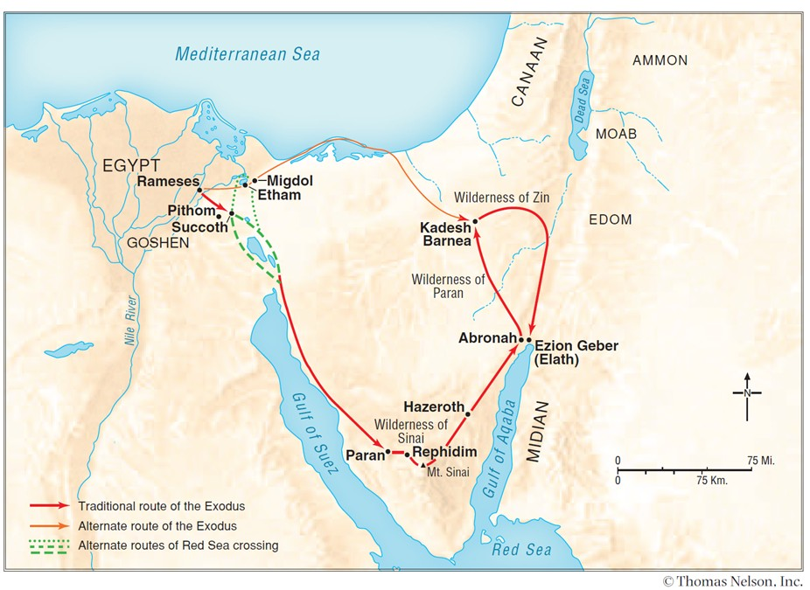

Although the people had said that ‘All that the LORD has spoken we will do’ (Exodus 19: 8; 24: 3 & 27), they yet made their disobedience even more terrible by rising up and making a molded calf out of gold jewellery given by the people (Exodus chapter 32).. Because of this idolatry, Moses destroyed the calf and the two tablets of stone, and God brought judgement upon the people.
God wrote the Ten Commandments on two new tablets of stone which Moses had cut out of the rock (Exodus 34: 1, 28-32). These two new tablets – called the Testimony - were kept in the Ark of the Covenant, in the Holy of Holies part of the Tabernacle – a portable construction which the priests and Levites transported throughout the wilderness journey (Exodus 25: 16; 2 Kings 8: 9: Hebrews 9: 4).

The Ten Commandments in Exodus chapter 20, can be put into two groups.

Regarding God –

- You shall have no other gods before me (vs. 3).
- You shall not make for yourself any carved image (vs. 4-6).
- You shall not take the name of the Lord your God in vain (swearing) (vs. 7). This also covers not using God’s name lightly or unthinkingly (e.g. in hymns we often sing without thought of the God the words are about).
- Remember the Sabbath day to keep it Holy (vs. 8).

This section can be summed up in the words of Deuteronomy 6: 5 – quoted by the Lord Jesus in Matthew 22: 37.

Regarding the Family and Others –

- Honour your father and mother (vs 12).
- You shall not commit adultery (vs. 14).
- You shall not murder (vs. 13). AV = kill.
- You shall not steal (vs. 15).
- You shall not bear false witness (lying) (vs. 16).
- You shall not covet (vs. 17).

This section can be summed up in the words of Leviticus 19: 18 quoted by the Lord Jesus in Matthew 22: 39.

Note – In our responsibility for others, God has placed the family first.

The Ten Commandments were for all peoples for all time. See also the section below about the New Testament.

After the giving of the Ten Commandments at Mount Sinai, the people of Israel (probably numbering 2 million) in their travels came near to the Promised Land. God told Moses to send 12 men to spy out the land and to report back to him. Ten of the spies gave a bad report, Joshua and Caleb gave a good report – read Numbers chapter 13. As a result, the children of Israel complained to Moses. They were unwilling to trust God to lead them forward into the promised land. In fact they rebelled against Moses’ leadership (Numbers 14: 4). As a result, God decreed that all those aged 20 years and upward would not enter the promised land of Canaan, except for Caleb and Joshua (Numbers 26: 64-65).

CIVIL AND CEREMONIAL LAWS GIVEN BY GOD TO MOSES

The following were specifically in respect of the people of Israel, although they do have lessons for us even today e.g. about other people’s safety.

The Law concerning servants – Exodus 21: 1-11
The Law concerning violence – Exodus 21: 12-27
Animal Welfare – Exodus 21: 28-36
Property – Exodus 22: 1-15
Moral and ceremonial principals – Exodus 22: 16-31
Justice for all – Exodus 23: 1-9
Three Annual Feasts – Exodus 23: 14-19
The Angel and the Promises – Exodus 23: 20-33
Generosity to the poor – Deuteronomy – 15: 7-8
Safety on buildings – Deuteronomy – 22: 8
Don’t charge interest on money lent to the poor – Exodus 22: 25; Deuteronomy 23: 19
Look after your neighbour’s animals – Deuteronomy 22: 1
Leave the remains of the harvest to the poor – Deuteronomy 24: 19-21.
Avoid wicked customs – Deuteronomy 18: 9-14.
God counted witchcraft as sin – 1 Samuel 15: 23
Sorcery (Enchantments) – Numbers 24: 1 (Balaam)
Sorcery, Divination – Numbers 23: 23
Idolatry – Deuteronomy 4: 15 – 19, 9: 16, 17: 3
False Gods – Deuteronomy 12: 31 (Pass through the fire)

IN THE NEW TESTAMENT

In the New Testament the Ten Commandments are summed up in the words of the Lord Jesus as ‘You shall love the Lord your God with all your heart, with all your soul, and with all your mind. This is the first and great commandment’ and then “And the second is like it: you shall love your neighbour as yourself”, (from Leviticus 19: 18; Deuteronomy 6: 5) see Matthew 22: 37-39. (see also Romans 13: 9)

The Lord Jesus Christ often referred to the Ten Commandments in His teaching. He showed the breadth of what the commandments covered. Here are some of them –

Matthew 5:21-22
“You have heard that it was said to those of old, ‘You shall not murder, and whoever murders will be in danger of the judgment.’

Matthew 15:19 ‘For out of the heart proceed evil thoughts, murders, adulteries, fornications, thefts, false witness, blasphemies.’ This verse shows us where the wrong-doing comes from!

Mark 2:27
And He said to them, “The Sabbath was made for man, and not man for the Sabbath.

Mark 10:19
You know the commandments: ‘Do not commit adultery,’ ‘Do not murder,’ ‘Do not steal,’ ‘Do not bear false witness,’ ‘Do not defraud,’ ‘Honor your father and your mother.’”

Luke 18:20
You know the commandments: ‘Do not commit adultery,’ ‘Do not murder,’ ‘Do not steal,’ ‘Do not bear false witness,’ ‘Honor your father and your mother.’”

The apostles also referred to the Ten Commandments in their teaching in the epistles –

Romans 7:7
What shall we say then? Is the law sin? Certainly not! On the contrary, I would not have known sin except through the law. For I would not have known covetousness unless the law had said, “You shall not covet.”

Romans 13:9
For the commandments, “You shall not commit adultery,” “You shall not murder,” “You shall not steal,” “You shall not bear false witness,” “You shall not covet,” and if there is any other commandment, are all summed up in this saying, namely, “You shall love your neighbor as yourself.”

James 2:11
For He who said, “Do not commit adultery,” also said, “Do not murder.” Now if you do not commit adultery, but you do murder, you have become a transgressor of the law.

How are we to love God?

Deuteronomy 6: 5, Luke 10: 27
You shall love the Lord your God with all your heart, with all your soul, with all your strength, and with all your mind, and your neighbour as yourself.

John 14: 15 – If you love me keep My commandments.

However, Galatians 3: 24 says, ‘Therefore the law was our tutor to bring us to Christ, that we might be justified by faith’. This verse shows us the purpose of the Law: our inability to keep it showing us our need of a Saviour. In our daily living, the Christian should observe Philippians 4: 8-9 – ‘Finally brethren, whatever things are true, whatever things are noble, whatever things are just, whatever things are lovely, whatever things are of good report, if there is any virtue and if there is anything praiseworthy – meditate on these things. The things which you learned and received and heard and saw in me, these do and the God of peace will be with you’. Paul’s example + God’s peace (blessing) should be ours.

Psalm 119

The Psalmist loved God’s laws; this is shown by the words he uses throughout this Psalm: - law, testimonies, ways, precepts, statutes, judgements, commandments, word, works, ordinances, salvation.

God gave the people of Israel and us the Ten Commandments –

Because Israel was to be God’s special, chosen people.
Because He has saved us
Because He has created us
Because they are good for us
Because they keep us from sin
Because they keep us close to God
Because they recognise God’s Holiness
Because God is all powerful
Because God is all knowing
Because God will not give His glory to another
Because only God is to be worshipped

Note - The map shown above is taken from -
Nelson’s Complete Book of Bible Maps and Charts copyright 1996, 1993 by
Thomas Nelson, Inc. .All rights reserved.

Note to the Reader: Nelson’s Complete Book of Bible Maps and Charts, Third Edition is intended for nonprofit, non-commercial use in classrooms and seminars. Photocopies made for such settings should be limited to 1,000 units and cannot be sold or used for any profitable enterprise. Questions about usage should be directed to Thomas Nelson. ISBN 9781418541712 Printed in the United States of America

The Bible Version used in this publication is The New King James Version.
Copyright 1979, 1980, 1982, by Thomas Nelson, Inc.

