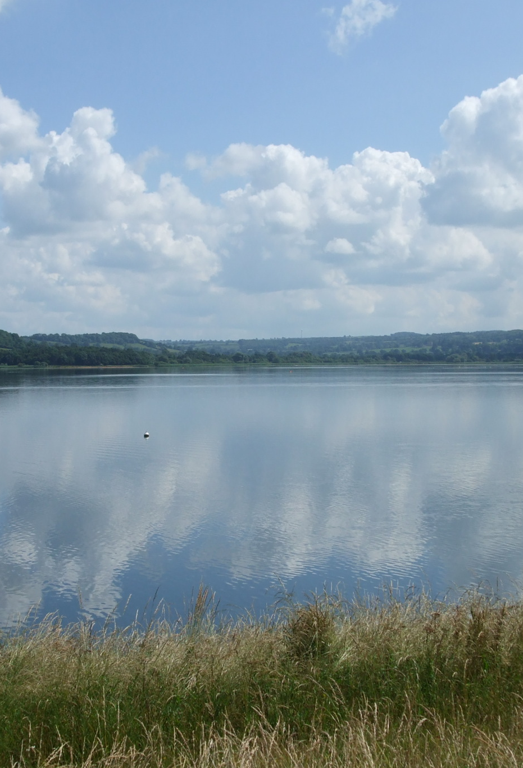
TO HELP ME

REMEMER THE

SIX DAYS OF

CREATION

By Jean Stapleton

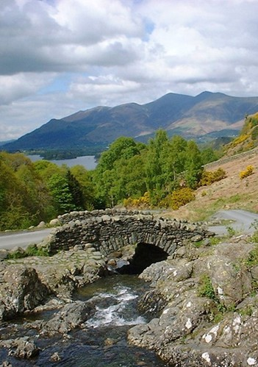
1.

God made the heavens and the earth,

And said, “Let there be light.”

The first day’s light shone at His word:

The darkness He called night.

2.

Upon the second day God made

The beautiful blue sky

Whose light and shade fall on the earth

As clouds go quickly by.

3.

The third day saw dry land appear

And water form the seas.

Upon the land God made to grow

The flowers and the trees.

4.

God made the sun to rule the day,

The moon to rule by night

On the fourth day He also made

The many stars so bright.

5.

The seas were soon with fish well filled

And birds flew in the sky.

All made by God’s almighty power

As the fifth day went by.

6.

The animals both large and small

Were made on the sixth day.

Then from the dust God formed a man

To love Him and obey.

7.

God saw that all was very good,

Creation’s work was done.

He set the seventh day apart

As rest for everyone.

The Creation

Genesis chapter 1 verse 1 to chapter 2 verse 3

Chapter 1

- In the beginning God created the heavens and the earth.
- The earth was without form, and void; and darkness was on the face of the deep. And the Spirit of God was hovering over the face of the waters.
- Then God said, “Let there be light”; and there was light.
- And God saw the light, that it was good; and God divided the light from the darkness
- God called the light Day, and the darkness He called Night. So the evening and the morning were the first day.
- Then God said, “Let there be a firmament in the midst of the waters, and let it divide the waters from the waters.”
- Thus God made the firmament, and divided the waters which were under the firmament from the waters which were above the firmament; and it was so.
- And God called the firmament Heaven. So the evening and the morning were the second day.
- Then God said, “Let the waters under the heavens be gathered together into one place, and let the dry land appear”; and it was so.
- And God called the dry land Earth, and the gathering together of the waters He called Seas. And God saw that it was good.
- Then God said, “Let the earth bring forth grass, the herb that yields seed, and the fruit tree that yields fruit according to its kind, whose seed is in itself, on the earth”; and it was so.
- And the earth brought forth grass, the herb that yields seed according to its kind, and the tree that yields fruit, whose seed is in itself according to its kind. And God saw that it was good.
- So the evening and the morning were the third day.
- Then God said, “Let there be lights in the firmament of the heavens to divide the day from the night; and let them be for signs and seasons, and for days and years;
- “and let them be for lights in the firmament of the heavens to give light on the earth”; and it was so.
- Then God made two great lights: the greater light to rule the day, and the lesser light to rule the night. He made the stars also.
- God set them in the firmament of the heavens to give light on the earth,
- and to rule over the day and over the night, and to divide the light from the darkness. And God saw that it was good.
- So the evening and the morning were the fourth day.
- Then God said, “Let the waters abound with an abundance of living creatures, and let birds fly above the earth across the face of the firmament of the heavens.”
- So God created great sea creatures and every living thing that moves, with which the waters abounded, according to their kind, and every winged bird according to its kind. And God saw that it was good.
- And God blessed them, saying, “Be fruitful and multiply, and fill the waters in the seas, and let birds multiply on the earth.”
- So the evening and the morning were the fifth day
- Then God said, “Let the earth bring forth the living creature according to its kind: cattle and creeping thing and beast of the earth, each according to its kind”; and it was so.
- And God made the beast of the earth according to its kind, cattle according to its kind, and everything that creeps on the earth according to its kind. And God saw that it was good.
- Then God said, ”Let Us make man in Our image, according to Our likeness; let them have dominion over the fish of the sea, over the birds of the air, and over the cattle, over all the earth and over every creeping thing that creeps on the earth.”
- So God created man in His own image; in the image of God He created him; male and female He created them.
- Then God blessed them, and God said to them, “Be fruitful and multiply; fill the earth and subdue it; have dominion over the fish of the sea, over the birds of the air, and over every living thing that moves on the earth.”
- And God said, “See, I have given you every herb that yields seed which is on the face of all the earth, and every tree whose fruit yields seed; to you it shall be for food.
- “Also, to every beast of the earth, to every bird of the air, and to everything that creeps on the earth, in which there is life, I have given every green herb for food”; and it was so.
- Then God saw everything that He had made, and indeed it was very good. So the evening and the morning were the sixth day.

Chapter 2

- Thus the heavens and the earth, and all the host of them, were finished.
- And on the seventh day God ended His work which He had done, and He rested on the seventh day from all His work which He had done.
- Then God blessed the seventh day and sanctified it, because in it He rested from all His work which God had created and made.

Scripture taken from the New King James Version. Copyright © 1979,1980, 1982 by Thomas Nelson, Inc. Used by permission. All rights reserved.

Copyright © Jean Stapleton 2026
All Rights Reserved

Photography
Copyright - © Mark Stapleton 2026
All Rights Reserved

Also in this series –

To help me remember the Ten Commandments

To help me remember the twelve disciples

