BIBLE HELPS
MOSES

BACKGROUND
The first 5 books of the Bible – Genesis, Exodus, Leviticus, Numbers and Deuteronomy – are known as the Books of Moses, or the Pentateuch (= 5 scrolls or volumes). Taken together, the Pentateuch Books were known as ‘The Law’, or in the Hebrew – the Torah (Joshua 23: 6). All the Bible was written under the inspiration of the Holy Spirit (see 2 Peter 1: 21 and 2 Timothy 3: 16). There are many verses in the Old and New Testaments confirming Moses as the author of the Pentateuch (Joshua 1: 7, 8: 31; 2 Kings 14: 6; 2, 21: 8; Malachi 4: 4; Matthew 8: 4; Luke 24: 44; John 8:31 etc).
MOSES’ FAMILY TREE
Moses is first mentioned in the Bible in Exodus chapter 2. He came from the tribe of Levi, one of Jacob’s (Israel’s)12 sons. The family tree goes back to Abraham and ultimately to Adam and Eve. From Abraham to Moses, the tree consists of 7 generations: Abraham = Isaac = Jacob = Levi = Kohath = Amram = Moses (Exodus 6: 16-20 and 1 Chronicles 6: 13).

THE NUMBER OF YEARS OF SLAVERY
In the New Testament, Galatians 3: 16-17 (NKJV) says – “Now to Abraham and his Seed were the promises made. He does not say, “and to seeds”, as of many, but as of one, “And to your Seed”, who is Christ. And this I say, that the law, which was four hundred and thirty years later, cannot annul the covenant that was confirmed before by God in Christ, that it should make the promise of no effect.” In other words, from the time Abraham was 75 when he left Haran (Genesis 12: 4) until the giving of the Ten Commandments by God to Moses (aged 80 years) on Mount Sinai, was a period of 430 years.
Until the time of Moses, Abraham’s descendants were only ‘sojourners’, temporary dwellers in Canaan and Egypt (Exodus 12: 40 margin - Sam LXX i.e. the Samaritan Pentateuch and the Septuagint.). The time from the covenant given to Abraham to when Jacob went into Egypt is 215 years, and the time from then until the giving of the Law, is 215 years, which continued for 80 years after the birth of Moses.

MOSES’ Life
Moses lived for 120 years (Deuteronomy 34: 7). His brother Aaron was 123 years old when he died Numbers 33: 38-39.

The First 40 years

MOSES BIRTH AND ADOPTION
His birth is recorded in Exodus 2: 1-3 – he was hidden for three months in his father’s house (Acts 7: 20), because of the cruelty of the Pharoah (Exodus 1: 22). For this Pharoah (who knew nothing about Joseph – Exodus 1: 8) was afraid that the increased number of the children of Israel might join others in war against them. He imposed a harsh regime of slavery (Exodus 1: 8-14), which continued another 80 years, when Moses led the Israelites out of Egypt. Moses became the son of Pharaoh’s daughter (Exodus 2: 1-10) and was given the name MOSES by her – meaning ‘because I drew him out of the water’ i.e. – the River Nile, and was brought up and educated in Pharoah’s Palace (Acts 7: 22). But later, Moses refused to be called the son of Pharoah’s daughter (Hebrews 11: 24).

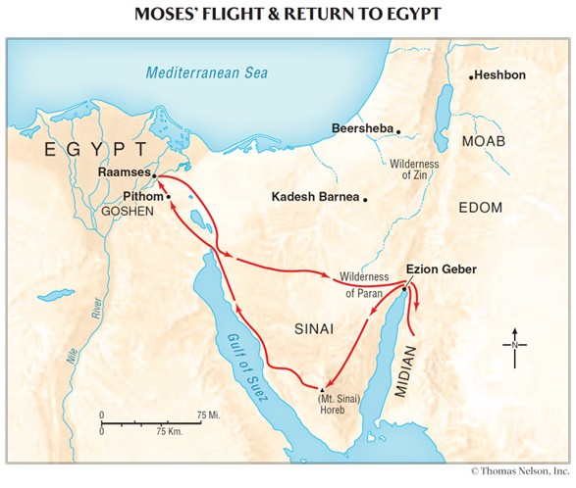
THE FLIGHT FROM EGYPT TO MIDIAN
After seeing the plight of his people’s slavery (Exodus 2: 11). Moses killed an Egyptian who was mistreating one of the Hebrews. When this incident came to the attention of Pharaoh, Moses fled the country and went and lived in the land of Midian (Exodus 2: 11-15). See the map above.

The Second 40 years

The second 40 years Moses lived in the land of Midian. There he met Jethro (Reuel. [Margin]), the priest of Midian. He helped Jethro’s daughters draw water for the flocks, following an attempt by some other shepherds to drive them away. In time Moses married one of Jethro’s daughters named Zipporah, and they had two sons (Exodus 2: 21, 18: 2-4 and 1 Chronicles 23: 15).
While living in Midian, the Pharoah who had imposed such a cruel system of slavery, died. He was replaced by another Pharoah who was also cruel (Exodus 2: 23-25). God was very much aware of the bondage and slavery imposed upon the children of Israel.
THE BURNING BUSH
Exodus chapters 3 and 4 tells us of Moses’ encounter with God at Mount Horeb (Mount Sinai) where He spoke to him out of a burning bush. Moses was reminded that he was on holy ground (chapter 3 verse 5) and so he removed his sandals. God revealed to Moses that He had heard the cry of the children of Israel, and that Moses was to lead them out of Egypt and to bring them to a new land that was to be theirs. God gave instructions as to how this was to be done, including the dialogue he was to have with the reigning Pharoah. See also Acts 7: 17-35.

Moses returned to Jethro his father-in-law in Midian, who gave him his blessing and encouragement. Aaron was to be Moses’ spokesman (Exodus 4: 10-17) because of Moses’ protest that he was not eloquent. Moses sets off to Egypt with his family, and was met by his brother, Aaron at the ‘Mount of God’ – Mount Sinai (Exodus 4: 27).

The Third 40 years

THE TEN PLAGUES
The start of the third 40 years of Moses’ life, began when ‘an Angel of the Lord appeared to him in a flame of fire in a bush, in the wilderness of Mount Sinai’ (Exodus 3: 1-21; Act 7: 29-30). Moses and Aaron carried out God’s instructions, and encountered Pharoah’s strong opposition to their request to let the people of Israel go (Exodus chapters 5 – 7). Pharoah’s heart was hardened even when God, through Moses and Aaron, brought ten plagues upon the land of Egypt. According to Ussher, in his ‘Annals of the World’ the plagues lasted a month. Religion in ancient Egypt was complex polytheism; local deities and nature gods were worshiped by the people. Gods were associated with all aspects and protection of life. These ten plagues were a direct challenge to the worship of Egyptian deities (Exodus 12: 12). In this way God’s supremacy was clearly demonstrated (see Numbers 33: 4).

- Waters become blood – Exodus 7: 14-25
- Frogs – Exodus 8: 1-7
- Lice – Exodus 8: 16-19
- Flies – Exodus 8: 20-32 *
- Livestock diseased – Exodus 9: 1 – 7 *
- Boils – Exodus 9: 8 – 12 * **
- Hail - Exodus 9: 13-35 *
- Locusts – Exodus 10: 1-20 * **
- Darkness – Exodus10: 21-29 * **
- Death of the first-born – Exodus chapter 12: 29-30 *
*These plagues did not affect the people of Israel
** These plagues – it was God who hardened Pharoah’s heart.
Further Bible records of the plagues can be found in Psalms 78 and 105.

THE EXODUS
Between plagues 9 and 10, God announced the coming death of the first-born to Moses, and details regarding the feast of the Passover which was to be kept each year after the people of Israel’s departure from Egypt (Exodus chapters 11 and 12). Every household was to sacrifice a lamb. The blood was to be sprinkled on the doorframe of each dwelling. God’s instructions, through Moses had to be strictly followed.
It is important to remember that the people of Israel escaped the tenth plague, only because they obeyed God and followed the instructions to them – Exodus 12. As a result, God told Moses that the first-born in the future was to be consecrated to Him (Exodus 13: 1-2). The people were redeemed because the blood of an animal was forfeited instead of them. The same principle applies today – we cannot know redemption from sin except through the shed blood of the Lord Jesus Christ, who takes away the sin of the world (John 1: 29). The picture of Christ as the Passover lamb is also found in 1 Corinthians 5: 7.
The people of Israel went out from Egypt ‘in haste’, spoiling the Egyptians as they went (Exodus 3: 21-22; 11: 2-3; 12: 35-36). The people also took with them the bones of Joseph as he had commanded them (Genesis 50: 25; Exodus 13:19; Joshua 24: 32; Hebrews 11: 22). This was the start of a long journey from Egypt to the promised land. It was to take 40 years to complete, the reason will be shown later in these notes. You can see the details of their journey and the 42 camps in Numbers 33: 1 – 49.
THE RED SEA
God, through Moses led the people of Israel out of Egypt. The first thing they had to confront was the Red Sea. Moses commanded the people (probably 2-3 million in number) to see the salvation of the LORD, as the Egyptian army were seen coming up behind them (Exodus chapter 14). The presence of God with His people was seen in a cloudy pillar by day and a pillar of fire by night. God opened a path on dry ground, through the Red Sea, and brought them safely to the other side. The Egyptian army all perished in the sea when God returned the waters back to what they were before. On the other side of the Red Sea there was much rejoicing as Moses and Miriam led the people in Songs of praise, worship and thanksgiving for what God had done for His people (Exodus chapter 15).

THE PEOPLE GRUMBLE

The journey to the Wilderness of Sinai took 3 months (Exodus 19: 1). On the way to the Mountain, the people of Israel started complaining to Moses because of the harsh conditions they were suffering: they grumbled about the lack of food and water. God graciously gave them His special food, which they called ‘manna’ and gave them adequate water which came from a rock, which God told Moses to strike. He also gave them quails (small birds) to eat (Exodus 16: 13; Numbers 11: 31-32; Psalm 105: 40).The Manna was supplied for the whole of the 40 years journey until they came to the promised land (Exodus 16: 35; Joshua 5: 12; Psalm 78: 15-16, 20, 24-25, 26-31,). Read about these incidents in Exodus chapters 16 and 17:1 - 7. A visit from Jethro, Moses’ father-in-law, was encouraging and helpful to Moses (Exodus chapter 18)

THE TEN COMMANDMENTS

At Mount Sinai, God spoke the words of the Ten Commandments (also known as the Decalogue) to Moses in the hearing of the people, before He wrote the words on two tablets of stone – see Exodus 20: 1-17 and Deuteronomy chapter 5. Because of idolatry by Aaron and the people, Moses was very angry (Exodus 32) with the people and broke the two tablets of stone. Later, 2 new tablets were cut, and again, God wrote on them the words of the covenant, the Ten Commandments (Exodus 34: 1-2, 28).

CONTENTS OF THE ARK

The two tablets of stone on which God had written the Ten Commandments, were to be stored in the Ark of the Testimony (Exodus 25: 16), together with a pot of Manna (Exodus 16: 33), and Aaron’s rod that budded (Numbers 17: 10; Hebrews 9: 4). These last two items were no longer kept at the time of the building of the Temple in Jerusalem (2 Chronicles 5: 10). The Mercy Seat was placed on top of the Ark, the place where God made known His presence (Exodus 25: 17-22).

A TEMPORARY PLACE OF WORSHIP
As a temporary measure, Moses erected his own tent, outside the camp where the people could come and worship God, and where he talked with God. They could also seek advice from Moses. Joshua, Moses’ servant faithfully served God at this ‘The Tabernacle of Meeting’. The presence of God was seen by the pillar of cloud (Exodus 33: 7-11).
GOD’S PLANS FOR THE TABERNACLE
God gave Moses instructions to build a Tabernacle (a portable tent). First, the plan of the Tabernacle (see below), then the gathering of materials, the clothing for the priests, and finally the erecting of the Tabernacle were all given to Moses by God. The details had to be carried out precisely as God had given them to Moses. Read about this in Exodus chapters 25 to 40. The people brought their gifts of materials for the Tabernacle to Moses. At one point Moses had to restrain them because they had brought ‘too much’ (Exodus 36: 6-7). God told Moses to appoint artisans (craftsmen and helpers) to carry out the work. See Exodus 35: 4 – 39: 43.
The Tabernacle was to be a portable building which was to signify the presence of God among His redeemed people. There was a visible sign given of God’s presence by a cloud by day, and a pillar of fire by night to be seen over the Tabernacle (Exodus 40: 38).

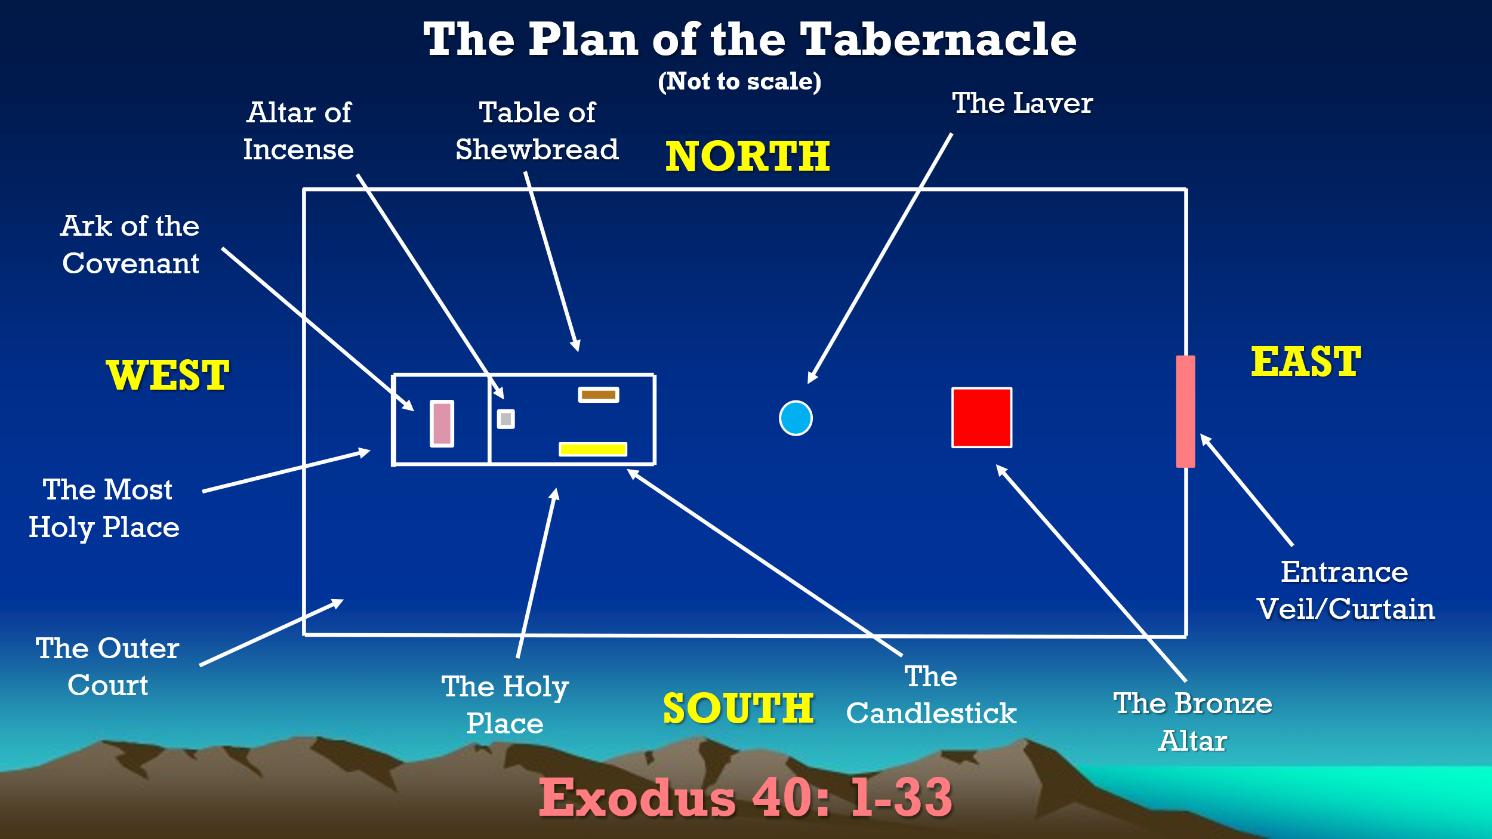

HOLY LIVING
The book of Genesis could be described as the Book of beginnings; the Book of Exodus as the ‘way out’ of Egypt; the Book of Leviticus focuses on the worship and walk of the nation of God. In the Book of Exodus, Israel was redeemed and established as a kingdom of priests and a holy nation. Leviticus shows how God’s people are to fulfil their priestly calling. It is God’s guidebook for His newly redeemed people, showing them how to worship, serve, and obey a holy God. Fellowship with God through sacrifice and obedience show the awesome holiness of the God of Israel. Indeed, “’you shall be holy, for I the LORD your God am holy’” (Leviticus 19: 2).

SACRIFICES AND OFFERINGS
The first eight chapters of Leviticus give details regarding the offerings and sacrifices, as God gave to Moses. The 5 main offerings are –
- The whole burnt offering
- The meat or meal (KJV) or grain (NKJV) offering.
- The peace offering.
These three are known as Sweet Savour (KJV) or Savor (NKJV) offerings. These mean something well pleasing to God and do not have in view the dealing with sin.
- The sin offering.
- The trespass offering.
These two are known as non-sweet Savour (KJV) or Savor (NKJV)

The order of the offerings in Leviticus is given from God outwards. We must look at them from the reverse order i.e. dealing with sin must come first. All the offerings were offered on the brazen altar (pointing to the Cross), placed near the entrance to the courtyard of the Tabernacle. The one offering of Christ (Hebrews 10: 12) is seen as a composite offering Its full significance is only progressively understood by the believer, being revealed by the Holy Spirit as spiritual progress is made. The Lord Jesus Christ may be thought of as being – a. The Offering, or b. The Offerer, or c. The Priest. A great part of the book of Leviticus is taken up with God’s instructions to Moses about the sacrificial system as well as dealing with every-day living. It has been said that if you want further understanding of the books of the Pentateuch then a good commentary can be seen in the New Testament book of the letter to the Hebrews.

THE ORDER OF THE MARCH
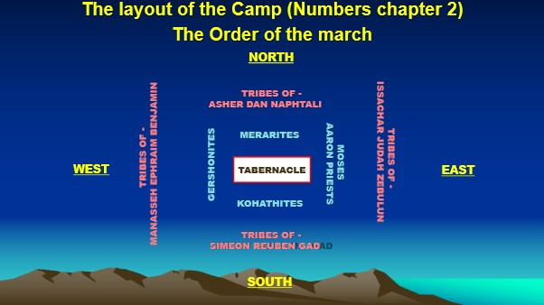

Not only did God provide instructions to Moses regarding the daily sacrifices and the Tabernacle service carried out by the Priests and the other members of the tribe of Levi, but also instructions as to how, and in what order the people of Israel were to travel on their journey from Egypt to the Promised land. The people camped at 42 places on their journey: the list of places is shown in numbers chapter 33. These details of the order in which they decamped are given in the Book of Numbers chapter 2. The order is shown in the diagram above.
Judah, Issachar and Zebulun moved first, followed by the Levites (sons of Gershom and Merari (shown in blue) carrying the Tabernacle (shown in white); then Reuben, Simeon and Gad, followed by Kohath (shown in blue) - carrying the holy things; followed by Ephraim, Manasseh and Benjamin and finally Dan, Asher and Naphtali.. This was the order the first time they set of from Sinai: Read about it in Numbers chapter 10. Thereafter, the order was slightly different: all the Levites (see Numbers chapter 2) followed groups 1 and 2. Further information as to the duties of the Priests can be found in Numbers chapter 4.

SILVER TRUMPETS
God spoke to Moses again and gave him instructions regarding the making of two silver trumpets, which would be used to direct the movement of the camps, when the leaders were to assemble at the door of the Tabernacle and to sound an alarm in times of enemy threats. See Numbers chapter 10.

SPYING OUT THE PROMISED LAND
As the people of Israel came closer to the promised land of Canaan, God spoke again to Moses, giving him instructions to send a representative from each of the 12 tribes to spy out the promised land. The twelve men included Joshua – known as Hoshea - (Ephraim‘s tribe) and Caleb (Judah’s tribe). They returned to Moses after 40 days spying, with examples of the produce of the land. They all brought back a good report. It was only Caleb and Joshua who affirmed that ‘we are well able to overcome’ the land, knowing that God was well able to lead his people into the new land. The other ten said that ‘we are not able to go up against the people’. Also, the people complained about Moses and Aaron and threatened to choose another leader. As a result, God decreed that all people aged 20 years old and older would not enter Canaan, except for Caleb and Joshua (Numbers chapters 13 & 14, 26: 64-65).

CHALLENGED LEADERSHIP
Korah (Grandson of Kohath) with men from the tribe of Reuben with 250 leaders challenged Moses about his right to lead the people. Read about this in Numbers chapters 16 & 17.

THE PEOPLE GRUMBLE
Another incident occurred when the people of Israel complained to Moses about the hardships of the journey. God sent fiery serpents among the people and many people died. God instructed Moses to make a fiery serpent and set it on a pole. Anyone who was bitten would recover if they looked at that pole (Numbers 21: 4-9). This reminds us of the time when the Lord Jesus used that illustration to show that all who look to the Saviour in repentance and faith, will be saved (Isaiah 53: 6; John 1: 29; John 3:14).

WANDERINGS AND EXPERIENCES
The Book of Numbers deals mainly with the wanderings and experiences of the Children of Israel in the wilderness. For Israel, an 11 day journey became a 40 year agony. See map below. At Kadesh, the Children of Israel complained to Moses regarding the supply of water. God told Moses to speak to the rock which would ‘yield its water’. Moses disobeyed God and instead struck the rock with his rod (Numbers 20: 2-12). As a result, God would not allow Moses to enter the promised land – only to view it from a distance.
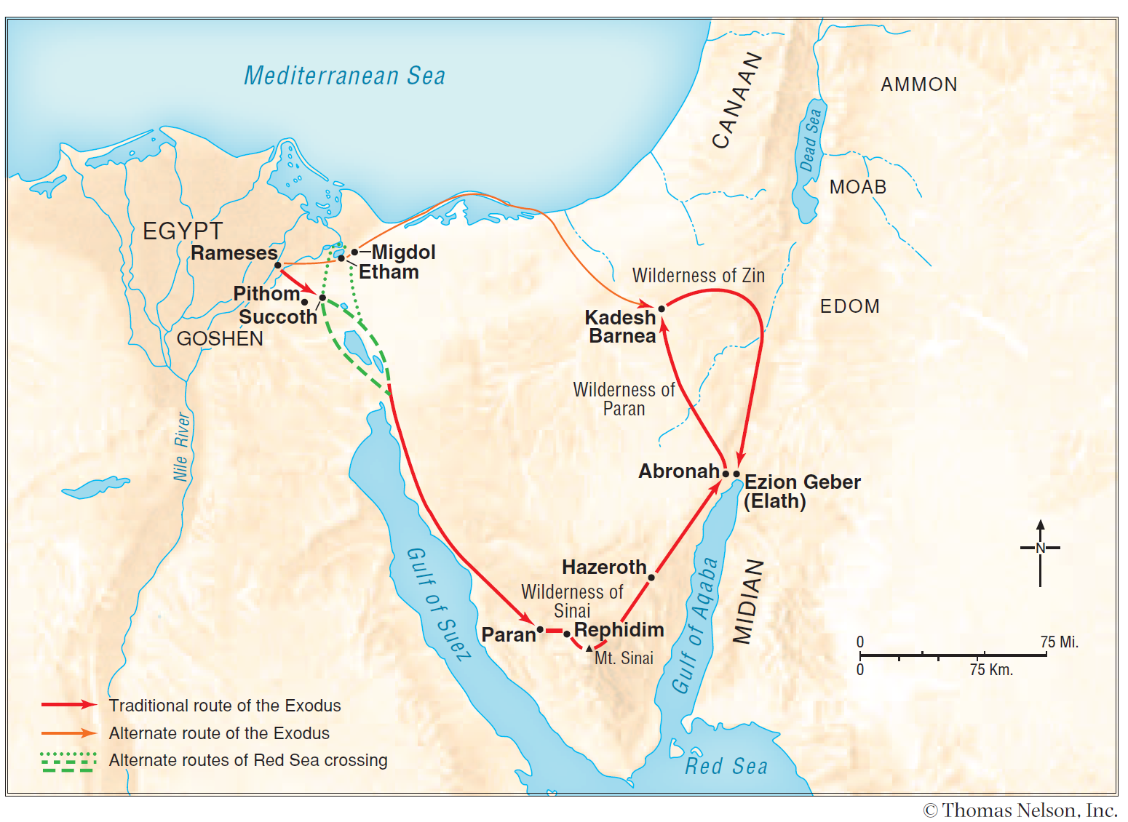

GOD’S LAW EXPLAINED AGAIN
The Book of Deuteronomy deals with the second reading and explanation by Moses of the law that God had given at Sinai. The people who had rebelled against God’s leading had been replaced by the next generation and therefore would not have heard the original giving of the law (Deuteronomy 1: 34-46). Moses tells the people that Joshua is to be their new leader, and that he would take them into the promise land (Numbers 27: 18-23; Deuteronomy 31: 1-8).
THE DEATH OF MOSES
Towards the end of the book, Moses gives his final blessing on the people (Deuteronomy 33). God graciously allows Mose to view the promised land from Mount Nebo, at the top of Pisgah, which is opposite Jericho. Moses dies in the land of Moab, and God buries him in a valley in the land of Moab opposite Beth Peor (Deuteronomy 34).
MOSES CHARACTER
The character of Moses is seen in the fact that the phrase’…the LORD spoke to Moses’, is used many times, showing his walk with God, and his trust in Him throughout the leading of the Children of Israel from slavery in Egypt to the land God had promised His redeemed people. Moses’ name is mentioned nearly 800 times throughout in the Bible. His name is shown in 19 books of the Old Testament and 12 books of the New Testament. Various aspects of his character, are shown in the following Bible verses -
- Moses declared to God that he was not eloquent - ‘. slow of speech and slow of tongue.” Exodus 4: 10.
- Moses was kind and helpful – Exodus 2: 17.
- Moses was content to live with Jethro and his family – Exodus 2: 21.
- Moses looked after sheep – Exodus 3: 1.
- Moses led the people in worship in praise of God – Exodus 15: 1.
- Moses acted as a judge when the people came to him about family matters – Exodus18: 13.
- Moses was meticulous in ensuring that God’s plans were carried out – Exodus 39: 43.
- Moses taught the people God’s commands, statutes and judgements – Leviticus10: 11 and Deuteronomy 4: 45.
- Moses was ‘very humble’ (NKJV) – Numbers 12: 3 (‘very meek’ – KJV).
- God describes Moses as ‘My servant’ - Numbers 12: 7.
- Many times on the wilderness journey, Moses interceded on behalf of God’s people.
- Moses displayed a righteous anger - Numbers 16: 15.
- Moses was a man of prayer - Psalm 90.
In the New Testament, Moses is quoted by the Lord Jesus Christ –
At various times - when He taught the Scribes and Pharisees, on the road to Emmaus, and to many individuals – Matthew 8: 4, 19: 7-8; Mark 1: 44, 7: 10, 10: 3-4; Luke 5: 14, 16: 31, 24: 44, John 3: 14, 5: 45-46, 6: 32, 7: 19, 22-23.
Moses is mentioned many times in Stephen’s address – Acts chapter 7, by Paul in Acts 26: 22 and 28: 23. Again in Paul’s letter to the Romans chapters 5, 9 and 10, Hebrews 3: 1-6,16, 8:5, 9: 19, 10: 28, 12: 21, Revelation 15: 3.
Moses and Elijah talked with the Lord Jesus Christ on the Mount of Transfiguration – Matthew 17: 3-4; Mark 9: 4-5; Luke 9: 30-33.
GOD’S DEALINGS WITH HIS PEOPLE
Throughout the life of Moses, God showed Himself to him and the children of Israel –
- The one who, forgives and redeems His people.
- The one who hears and answers the cries of His people.
- He is the only true God, there is none beside Him, He is a jealous for His people.
- God who will always judge sin.
- God requires His people to live holy lives.
- God always keeps His promises to His people.
- God never forsakes His people.
- The God who is slow to anger and plenteous in mercy.
- The God who guides and directs His people.

GOD’S PREPARATION AND TRAINING OF HIS SERVANT MOSES
- Moses had a humble beginning among the Children of Israel at a time of harsh slavery.
- He was brought up and educated in Pharoah’s household as the son of Pharoah’s daughter. He would know how to conduct himself in the home and palace of the Pharoah.
- His experience of travelling and living in the wilderness in Midian, was a wonderful preparation for the 40 years of guiding God’s people through ‘that ‘great and terrible wilderness’ – Deuteronomy 1: 19.
- His experience as a shepherd in Midian, was to help him in guiding and dealing with many situations in the wilderness.
- God graciously gave Moses a helper on his return to Egypt – his brother Aaron, and a wise advisor in his father-in-law – Jethro.

Note - The maps shown above are taken from -
Nelson’s Complete Book of Bible Maps and Charts copyright 1996, 1993 by
Thomas Nelson, Inc. .All rights reserved.
The Bible Version used in this publication is The New King James Version.
Copyright 1979, 1980, 1982, by Thomas Nelson, Inc.
Note to the Reader: Nelson’s Complete Book of Bible Maps and Charts, Third Edition is intended for nonprofit, non-commercial use in classrooms and seminars. Photocopies made for such settings should be limited to 1,000 units and cannot be sold or used for any profitable enterprise. Questions about usage should be directed to Thomas Nelson. ISBN 9781418541712 Printed in the United States of America

The Bible Version used in these notes is The New King James Version.
Copyright 1979, 1980, 1982, by Thomas Nelson, Inc.

The two coloured diagrams shown above have been taken from a series of PowerPoint presentations about the Tabernacle. These can be viewed at - https://www.oneagleswings.me.uk/grandpastabernacle/

© Mark Stapleton, April 2026

