BIBLE HELPS
JOSEPH
BACKGROUND
JOSEPH: Beloved, Hated, Exalted – the title of a book by F B Meyer B. A., gives us a description of the life of Joseph, as declared in the Word of God, the Bible. The first mention of Joseph is found in the book of Genesis 30: 24 when he was born to Rachel, his mother, and Jacob his father. McArthur’s study Bible says that ‘Joseph’ means ‘He will add or ‘may He add’. This was to be fulfilled some 15 years later, when Benjamin was born. In all, twelve sons were born to Jacob, the first being Reuben and the youngest Benjamin.

FAMILY TREE
Joseph’s Great Grandfather was Abraham (Abram – Genesis 12: 1; 17: 5) the patriarch to whom God promised that his family would be become a great nation and that through them all the nations of the world would be blessed – namely, in due time, the promised Saviour, the Lord Jesus Christ, would come (Genesis 12: 1-3). Abraham’s son, Isaac was born to him in his old age. Isaac’s descendants were Esau and Jacob (twins). Whilst living in Padan Aram, Jacob married Leah (who gave her maid, Zilpah, to Jacob as wife – Genesis 30: 9) and Rachel (who gave her maid, Bilhah, to Jacob as wife – Genesis 30: 4). From these, Jacob’s twelve sons were born:
REUBEN, SIMEON, LEVI JUDAH (Leah); DAN, NAPHTALI (Bilhah); GAD, ASHER (Zilpah), ISSACHAR, ZEBULUN (Leah); JOSEPH, BENJAMIN (Rachel) (Genesis 29: 32 – 30: 24). All these are mentioned in Genesis 35: 23-36.
Jacob, whose name God changed to Israel (Genesis 35: 10), with his wives and his now large family and with much livestock, returned to Canaan, twenty years after he left. He came to Bethel. and from there the large family travelled on to Ephrath (Bethlehem). Coming near to Bethlehem, Rachel died in childbirth giving Jacob the last of his sons, whom he named Benjamin (Genesis 35: 16-18). Israel travelled on to Kirjath Arba (that is Hebron – Genesis 35: 27-29) where his aged father Isaac lived, who died at the age of 180.

YOUNG JOSEPH
Joseph would have been about fifteen years old when Benjamin was born and their mother died. No doubt young Benjamin would have been cared for by a member of Israel’s family. Scripture tells us that Israel loved Joseph more than all his children (Genesis 37: 3) because he was the son of his old age. Israel’s special attention to Joseph was noted by his elder siblings, and they began to complain to him and would not even talk to him. Joseph brought a bad report of the sons of Bilhah and Zilpah to Jacob (Genesis 37: 2). One reason for their complaint was that Israel had given Joseph a very special garment, described as a ‘coat of many colours’ (Genesis 37: 3). This could have been a special garment made of separate pieces of coloured material, or, more likely, a long garment reaching down to the ankles made of white material, embroidered with a narrow strip of colour around the edge of the skirt and sleeves; such a garment was that which was worn by royalty and the nobility. Such a garment would show that Jacob regarded Joseph as a leader or supervisor of the brothers. The ten brothers would have been working out in fields, where such a garment would have been too restrictive.
Life continued for Israel’s household. Joseph had two dreams. The first was about sheaves in the field, where his sheaf was surrounded by other sheaves bowing down to him (Genesis 37: 5-7). The second dream showed the sun, moon and eleven stars bowing down to him (Genesis 37: 9). It was obvious that the dreams were referring to his brothers and his father bowing down to him. Under the hand of God this was to be fulfilled in future days. The hatred by Joseph’s brothers grew; it must have been a traumatic time for the young lad.
There came a day when Joseph’s brothers went to feed their father’s flock in Shechem. His father wanted him to take a journey from Hebron to see how his brothers wer getting on, and then to report back to him. Joseph dutifully obeyed his father and set off to find his brothers. The story of Joseph’s journey is told in Genesis 37: 12-17. Joseph was directed by a certain man ‘in the field’ to Dothan. See the map below showing Hebron, Shechem and Dothan.
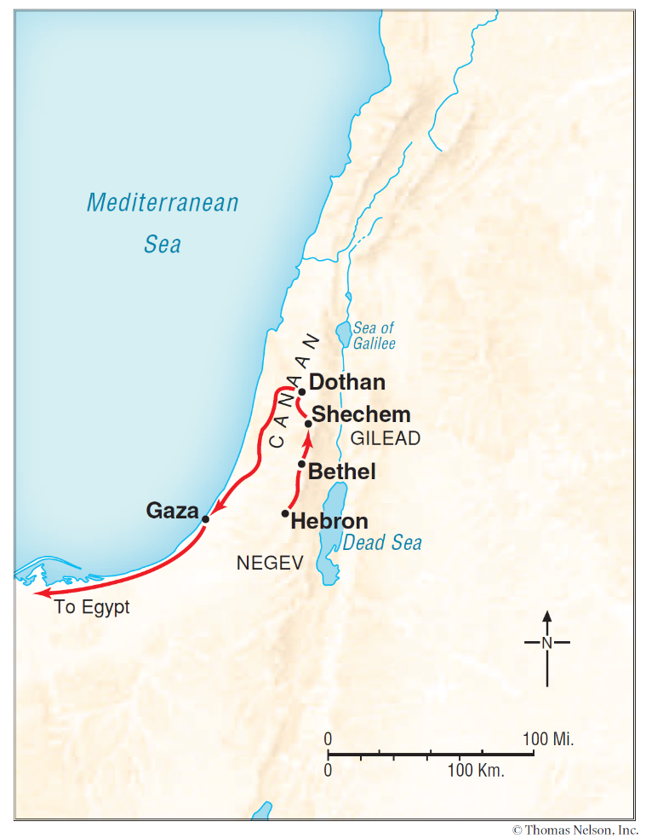

SOLD INTO SLAVERY
Joseph’s brothers saw him coming a long way off and immediately started to plan to kill him, and put him in a pit. However, Reuben, the oldest brother intervened. He thought that if they put Joseph into a pit alive, he could rescue him and get him back to his father (Genesis 37: 18-22). This was carried out – Joseph was stripped of his ‘coat of many colours,’ and placed in a pit. While the brothers were having a meal break, they spotted some traders coming their way. The traders were Ishmaelites (Midianites), travelling from Gilead to Egypt, carrying spices, balm and myrrh on their camels (Genesis 37: 25-28). Both names – Midianites and Ishmaelites – had a common ancestor, namely Abraham as their father (Genesis 16: 15, 25: 1-2), the names are often used interchangeably. While Reuben was away from them, the rest of the brothers conspired together, and followed Judah’s suggestion, that they sell Joseph to the traders to be taken to Egypt and sold as a slave. Reuben now returned to his brothers and was filled with remorse at the action that had been taken. However, together, the brothers dipped Joseph’s special tunic in the blood of a kid of the goats and returned home to tell their father that it looked as if Joseph had been killed by a wild beast (Genesis 37: 33-35). In fact, Joseph had been sold to the Midianite traders for twenty (pieces) shekels of silver (Genesis 37: 28), who took him and sold him as a slave to Potiphar, an officer of Pharoah, and captain of the guard (Genesis 37: 36). You will note that the Lord Jesus Christ was betrayed by Judas for thirty pieces of silver – read Matthew 26: 15 and 27: 3-10).

POTIPHAR’S HOUSHOLD
Genesis chapter 39 opens with a new phase in Joseph’s life. At the age of 17 (Genesis 37: 2), he had become a slave in Potiphar’s household. The Bible tells us that the LORD was with Joseph (Genesis 39: 2). In spite of all the trouble he had gone through, God had not forsaken him, and in His goodness and mercy, made him to prosper in this house. It is also notable that Potiphar also recognised that God was with Joseph by the way he carried out his duties. So Joseph prospered and was successful, and found favour in Potiphar’s eyes, to the extent that he made him overseer of his household. Potiphar’s household was blessed by God for Joseph’s sake (Genesis 39: 2-6).
Where God is at work in the life of one of His people, you can be sure that Satan will want to upset that person’s life and seek to keep them from God’s appointed way. It was the same in the life of Joseph. Being a handsome young man, Potiphar’s wife made advances to him. Joseph resisted these advances knowing that it would lead to sinning against God (Genesis 39: 6-18). Such was Joseph’s God given wisdom and standing, that he fled from the presence of Potiphar’s wife, but later in the day was accused falsely by her to his master Potiphar. In the New Testament, James 1: 12-18 is a great help and encouragement for those who are tempted.

PRISON LIFE
This led to Joseph’s imprisonment, but again, God had not forsaken him, and made him prosper, even in prison (Genesis 39: 19-23), where he was to spend a number of years (Psalm 105: 18). In prison, Joseph was given favour with the prison keeper, who made him overseer of the other prisoners. Verse 23 repeats that ‘the LORD was with him, and whatever he did, the LORD made it prosper’. God had helped Joseph to resist temptation, and now wrongly accused and imprisoned, God helped him still.
The next incident in Joseph’s life would lead him to Pharoah. Read about this in Genesis chapter 40. Both Pharoah’s chief butler and chief baker had dreams. Following Joseph’s God given interpretation of the dreams, the baker was hanged and the butler was restored to his former position. Joseph’s request to the butler to remember him before Pharoah was forgotten for two years.

THE BUTLER REMEMBERS
Two years later, the next scene in the court of Pharoah focuses on his dreams (Genesis 41). No-one could interpret the dreams, until the butler remembered his experience with Joseph in prison some years previously. Joseph now being 30 years old (verse 46), was summoned to Pharoah’s court to explain his dreams. One dream was about fat and thin cows, and the other about fat and thin ears of corn, indicating 7 years of plenty followed 7 years of famine. Again, Joseph acknowledges that it was God who would give the interpretation of the dreams. These two dreams had been given by God so that Pharoah would know what was going to happen in the land. Verses 16, 25, 28 and 32 show that Joseph had not strayed from his trust in Almighty God.

JOSEPH APPOINTED No. 2 IN EGYPT
Pharoah declared to his servants, ‘Can we find such a one as this, a man in whom is the Spirit of God?’ (verse 38). The chapter concludes by Pharoah appointing Joseph as the manager over the country’s food stock. Joseph would be the most powerful man in the country, apart from Pharoah himself. He gave Joseph the name ‘Zaphnath-Paaneah’ – it is probably Egyptian for ‘God Speaks and He Lives’ or ‘A revealer of Secrets’. He also gave Asenath, daughter of Poti-Pherah priest of On as wife. (Genesis 41: 45). They subsequently had two boys – Manasseh and Ephraim.

JACOB’S HOUSEHOLD
In Genesis 42 the scene changes again to Jacob’s (Israel’s) household who were beginning to feel the effects of the famine, which covered a wide area. They had heard that there was food in Egypt, so Jacob sent the ten brothers to Egypt while young Benjamin stayed at home. His father was anxious that no harm should come to him, as had happened to Joseph years before (verses 3-4). By this time, Benjamin would have been fifteen years old.

BUYING FOOD IN EGYPT
On arrival in Egypt, the ten brothers presented themselves before Joseph who recognised them and spoke roughly to them. At this point, Joseph remembered the dreams of his youth, and how his brothers would one day bow down to him. Of course, all those who came to Egypt to buy corn, would have to bow down before him; Joseph had been exalted, and had been promoted to the highest office in the land, second only to Pharoah. He now accused his brothers of coming to Egypt to spy out the land (Genesis 42: 8-9). Through clever questioning, Joseph drew out of his brothers about the family they had left behind in Caanan. He found out that his father was still alive, and that his younger brother was with him. Joseph was determined to see Benjamin and demanded that he be brought with them next time they came to buy food. The brothers’ conscience began to trouble them when they remembered what they had done to Joseph. In order to make sure that he saw Benjamin again, he took Simeon and put him in prison. The brothers returned to their father with the distressing news that Simeon was being held by Joseph in prison. Read Genesis 42 to see how this event unfolded. Notice that in verse 18, Joseph declares that ‘I fear God’; a testimony that showed that his trust and faith in God had not wavered. It is also interesting to note that Joseph would have spoken to his brothers in the Egyptian language through an interpreter, but would have easily understood his brothers’ language.

THE FAMINE CONTINUES
There came a time when Jacob and his household needed to buy food again in Egypt. Genesis chapter 43 and 44 gives us the details. Judah reminded his father Jacob that Joseph would not see them again unless their brother Benjamin was with him. Jacob was very apprehensive about letting Benjamin go with his brothers, but finally he agreed, after Judah promised to be responsible for him. (Genesis 43: 8-10). Upon arrival in Egypt, Joseph again recognised his brothers, and invites them to a meal with him. The rest of this visit is told in graphic detail in Genesis 44: 1-34.

JOSEPH REVEALS HIMSELF TO HIS BROTHERS
Genesis chapter 45 opens with Joseph making himself known to his brothers in an emotional speech. There is much rejoicing. Pharoah commands Joseph to arrange for his father and all his brothers to come and live in the land of Egypt. The brothers are provided with everything they needed for the journey (Genesis 45: 16-24).

THE JOURNEY TO EGYPT
Chapter 46 gives us details of the journey of Jacob and his sons, to their new home in Goshen, in the land of Egypt. Jacob was then 130 years old (Genesis 47: 9). This happened about 1706 BC. There were 66 persons in Jacob’s family, plus Joseph and his family, who were already in Egypt, making a total of 70 persons who made that journey (besides Jacob’s son’s wives – Genesis 46: 26) and there was rejoicing when Joseph was united with his father. Jacob died at the age of 147 years, having lived in Egypt for 17 years (Genesis 47: 28). Pharaoh granted permission for Jacob (Israel) to be buried in the family burial cave in Mamre back in the land of Canaan (Genesis 47: 29-31; 50: 12-13). Note that this was same place where Abraham and Sarah, Isaac and Rebekah, and Leah were also buried (Genesis 49: 31).

THE FAMILY MOVES TO EGYPT
FATHER | MOTHER | CHILDREN | GRAND-CHILDREN | GREAT GRAND CHILDREN | No. | BIBLE REFS.
Jacob | Leah ¹ | Reuben | Hanoch, Pallu,  Hezron, Carmi |  | 6 | Genesis  46: 8-9
Jacob | Leah ¹ | Simeon | Jemuel, Jamin, Ohad  Jachin, Zohar, Shaul |  | 7 | Genesis  46: 10
Jacob | Leah ¹ | Levi | Gershon, Kohath, Merari |  | 4 | Genesi  46: 11
Jacob | Leah ¹ | Judah | Shelah,  Perez ², Zerah | Hezron, Hamul | 6 | Genesis  46: 12
Jacob | Leah ¹ | Issachar | Tola, Puvah, Job, Shimron |  | 5 | Genesis  46: 13
Jacob | Leah ¹ | Zebulun | Sered, Elon, Jahleel |  | 4 | Genesis  46: 14
Jacob | Leah ¹ | Dinah |  |  | 1 | Genesis  46: 15
Jacob | Zilpah ³ | Gad | Ziphion, Haggi, Shuni, Ezbon, Eri, Arodi, Areli |  | 8 | Genesis  46: 16
Jacob | Zilpah ³ | Asher | Jimnah, Ishuah, Isui, Beriah ⁴, Serah ⁵ | Heber, Malchiel | 8 | Genesis  46: 17
Jacob | Rachel ⁶ | Joseph ⁷ | Manasseh, Ephraim |  | 3 | Genesis  46: 19-20
Jacob | Rachel ⁶ | Benjamin | Belah, Becher, Ashbel, Gera, Naaman, Ehi, Rosh, Muppin, Huppim,  Ard |  | 11 | Genesis  46: 21-22
Jacob | Bilhah ⁸ | Dan | Hushim |  | 2 | Genesis  46: 23
Jacob | Bilhah ⁸ | Naphtali | Jahzeel, Guni, Jezer, Shillem |  | 5 | Genesis  46: 24
 |  |  | TOTAL PERSONS = |  | 70

NOTES
- Leah died in Canaan, in Mamre (Genesis 49: 31)
- Perez children were Hezron and Hamul
- Zilpah - no mention of her death, but probably died in Canaan (Genesis 30: 10)
- Beriah was the son of Asher. His children were Heber and Malchiel.
- Serah was the daughter Asher.
- Rachel died in the land of Canaan, buried near Bethlehem (Genesis 35: 19)
- Joseph was already in Egypt, married to Asenath (daughter of Potipherah, Priest of On), with their two sons, Manasseh and Ephraim (Genesis 46: 20)
- Bilhah - no mention of her death, but probably died in Canaan (Genesis 29: 29).

GOD MEANT IT FOR GOOD
After Jacob had died, Joseph’s brothers gathered together with him, fearing that now that their father, Jacob was no longer with them, he would hate them all the more. They expected him to actually repay them for the evil done they had done to him all those years ago. However, they confessed the wrong they had done, and Joseph forgave them. Joseph said to them that although the brothers meant evil against him, ‘God meant it for good, in order to bring it about as at this day, to save many people alive.’ So Joseph comforted his brothers and spoke kindly to them (Genesis 45: 5, 7; 50: 15-21).

BURIED IN CANAAN
Joseph continued to live in Egypt, he and his ‘father’s household’. He died at the age of one hundred and ten years old, and was embalmed and put in a coffin in Egypt (Genesis 50: 22-26). Before he died, he was confident that God would bring them back to the land He had promised them. He put them under oath to take his bones with them. (Genesis 50: 25). This was fulfilled at the time the children of Israel left slavery in Egypt, to start the journey to the land promised by God (Exodus 13: 19). In the promised land, the bones of Joseph were buried in the plot of land in Shechem which Jacob had bought from the sons of Hamor for 100 pieces of silver (Joshua 24: 32).

BELOVED, HATED AND EXALTED
Joseph was Beloved, Hated and Exalted. A reminder that the Lord Jesus Christ was Beloved of His Father, Hated by those whom He came to save. He is now Exalted and sits at His Father’s right hand, interceding on behalf of His redeemed people; He will come again one day to receive His people to Himself in glory.

© Mark Stapleton, February 2026
Note - The map shown above is taken from -
Nelson’s Complete Book of Bible Maps and Charts copyright 1996, 1993 by
Thomas Nelson, Inc. .All rights reserved.
The Bible Version used in this publication is The New King James Version.
Copyright 1979, 1980, 1982, by Thomas Nelson, Inc.

Note to the Reader: Nelson’s Complete Book of Bible Maps and Charts, Third Edition is intended for nonprofit, non-commercial use in classrooms and seminars. Photocopies made for such settings should be limited to 1,000 units and cannot be sold or used for any profitable enterprise. Questions about usage should be directed to Thomas Nelson. ISBN 9781418541712 Printed in the United States of America

