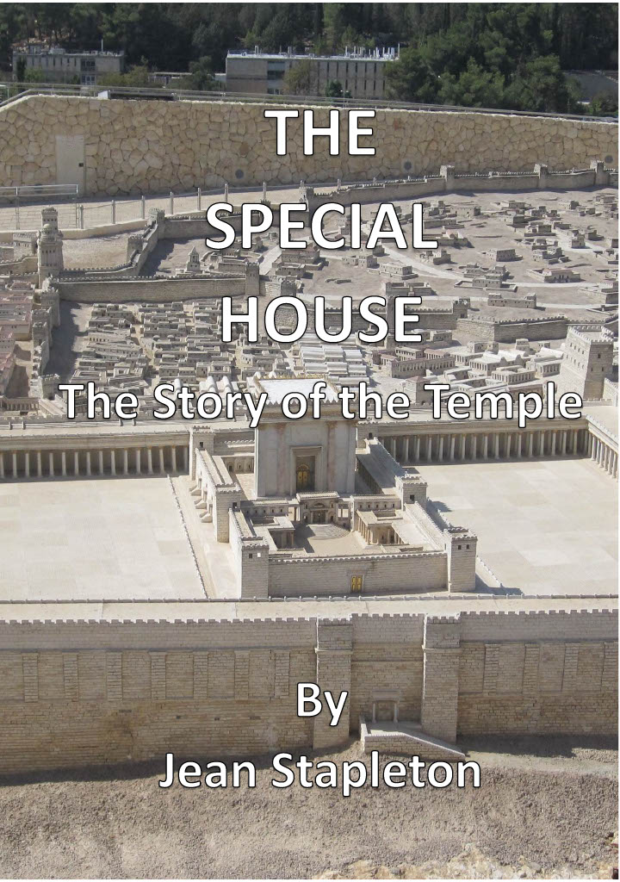
THE SPECIAL HOUSE

The Story of the Temple

By

Jean Stapleton

Copyright © Jean Stapleton 2025
All rights reserved

Scripture taken from the New King James Version Copyright © 1979 1980 1982 by Thomas Nelson, Inc. Used by permission. All rights reserved.

Photographs of Israel by T J Stapleton – used by permission.
Copyright - © Tim Stapleton 2025

Contents
INTRODUCTION 3
Chapter 1 - What the King wanted 4
Chapter 2 - Troubles in the Royal family 7
Chapter 3 - An Important meeting 10
Chapter 4 - The Work Begins 13
Chapter 5 - A Time of joy 15
Chapter 6 - How we come to God 18
Chapter 7 - Israel Divided 21
Chapter 8 - Bad days and good days at the Temple 23
Chapter 9 - Warnings ignored. 26
Chapter 10 - Rebuilding 29
Chapter 13 - The Son of God in the House of God 38
Chapter 14 - A Change in the Temple 41
FURTHER INFORMATION 45
Online E-books by the same Author 46

INTRODUCTION

The true story of the Special House tells us of times of great joy and times of great sadness. It tells us of beautiful buildings and of buildings in ruins.
The story of the Special House also tells us about men who God made strong and brave, and about others who were weak and foolish.
The story takes us through many years and continues today. It is no longer the story of a building made of stone, but of men and women, and boys and girls who love and trust the Lord Jesus Christ.
The contents page at the beginning of your Bible, will help you to find Bible verses. It lists the thirty-nine Old Testament books, that tell us about the time before the Lord Jesus came into the world. It also lists the twenty-seven New Testament books, that tell us about the things that happened when Jesus came and after He went back to heaven.

Chapter 1 - What the King wanted

The king was in his royal house. We do not know whether this house was as magnificent as some palaces, but we can be sure it was a house fit for a king. This king was not satisfied with just having his own house. There was another house that he wanted to build: a Special House, a Temple where God’s people would worship Him. King David told Nathan the Prophet what he wanted to do, and the prophet was pleased to hear about it.
King David thought that it was not good that, while he had a house, the Ark of God was kept in a tent. The Ark was a wooden box covered inside and outside with gold. It was the sign of God being present with His people. Inside the Ark were two pieces of stone, that God Himself had written the Ten Commandments on: God’s ten rules for life. All through the forty years that the Israelites had lived in tents in the wilderness, the Ark had its place in the Tabernacle. The Tabernacle was the special tent that God had told Moses that the people should make. Whenever the people moved camp, the Tabernacle moved with them.
At the time when David was king, the Israelites had been settled in their own land for many years. They no longer needed a special tent containing the Ark, to move from place to place with them. The king felt sure that the Ark should now have a special house, and he knew that Jerusalem was the place that God had chosen for it.
Have you ever wanted to do something and learned that someone else had been chosen to do it instead of you? King David was to learn that it would be his son, not him, who would build the Temple. God had spoken about it to Nathan the prophet and Nathan faithfully repeated God’s words to the king.
God said that instead of David building a house for Him, He would build David’s house. This would not be a house of bricks or stone, but David’s family, just as in the United Kingdom we call the royal family ‘The House of Windsor’. God promised that there would always be a man from David’s family to be the king.
It is about three thousand years since King David reigned in Jerusalem. We do not see any king of Israel there now, so what did God’s promise mean? We find the answer to that question in the first chapter of Matthew’s Gospel. Here we have the ‘family tree’ from Abraham (verse 2) to King David (verse 6) and then to the birth of the Lord Jesus (verse 16). Jesus, who came into the world through the family of King David, is King forever. He is the King of Kings (Revelation19: 16).

Find outs:
- Find out the size of the Ark of God from Exodus 25: 10. Put the measurements (length, width and height) into centimetres (1 cubit = 46 centimetres).
- When David was young, what work did he do? (2 Samuel 7: 8).
- Who would build the Temple? (1 Kings 5: 2 and 5).

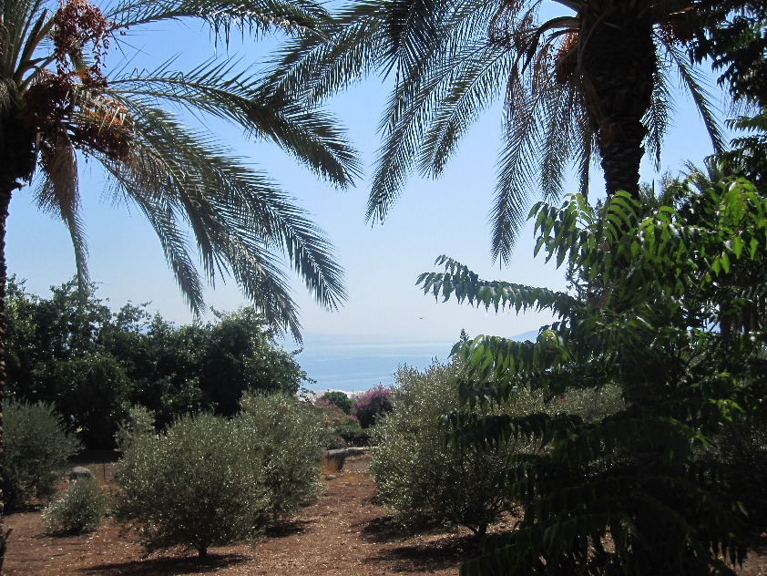

Chapter 2 - Troubles in the Royal family

David listened to all that Nathan said and then he prayed. He was full of thankfulness and praise to God for His wonderful promises. He did not speak of disappointment that God had not chosen him to build the Temple. He was so amazed with God’s promise to build his house.
King David has told us that God did explain to him why he was not to build the Temple. During his reign he had led his soldiers into many battles against Israel’s enemies. It would be different for his son. He would have a peaceful reign, and that would be the right time for the Temple to be built. God also told David that the son who would build the Temple, should be called Solomon. The name Solomon means ‘peaceful’ (1 Chronicles 22: 7 – 10).
King David had nineteen sons and Solomon was not the oldest. David faced many troubles in his family before Solomon became king. This was because two of David’s older sons had their own ideas about who the next king should be.
Absalom was a very handsome young man. He began to plan how to make the people think that he would make a better king than his father. In those days, people could go to the king for help with their problems. Absalom chose a place where he could meet the people as they were on their way to see his father. He acted very kindly towards all those he met. He persuaded them that he would be the person who could give them the help they needed.
Absalom’s plan went further than just meeting and speaking with people. He gathered many people to support him and then he led a rebellion against his own father. There were still many people who were loyal to King David and there was a battle between them and Absalom’s followers. Even though Absalom was causing so much trouble in the land, King David told the men who led the army, to make sure he was kept safe. Joab, the commander-in-chief, disobeyed. He knew that Absalom’s death would end the rebellion and so, in spite of what King David had said, he killed him. The king sorrowed for his rebellious son.
When King David was old, his son Adonijah decided to make himself king. He invited important people to a feast as well as his brothers, except Solomon. His plan was that the news would go out that he was now king.
Nathan the prophet knew what was happening. He and Solomon’s mother told King David about it. David knew that he must act quickly: Solomon must be proclaimed the next king of Israel. This was done: Solomon was anointed king. There was a time of great rejoicing as the people said, “Long live King Solomon” (1 Kings 1: 34).
When Adonijah and his friends heard what had happened, they all hurried to their homes, afraid that they would be punished. As King David was old and frail, he said that Solomon must be king in his place. Neither Absalom nor Adonijah could change what God had said should happen.

Find outs:
- Why was King David not chosen to build the Temple? (1 Chronicles 22: 7-9).
- What did Absalom do to make the people believe he would be a good king? (2 Samuel 15: 2-6).
- Who were the two people who told King David about Adonijah? (1 Kings 1: 15-18 and 22-25).

Chapter 3 - An Important meeting

King David called the leaders and all the important men in Israel together. He had much to tell them. He wanted the people to understand that it was God who had chosen Solomon to be king. He explained how he had wanted to build a Temple, and why God had said “ no, not you, but your son”. The king urged Solomon to be true to God, and he gave him the plans for the Temple.
Solomon would not have to decide what the Temple building should be like. David said that God had given him the plans and helped him to understand all the details. He had written it all down, ready to pass it on to Solomon. It was because David understood the building and its furniture, that he knew what would be needed for the work, and so he collected many things.
Even though David would never see the Special House, it was never far from his thoughts. We know that, because of all the preparations he had made. Now, with Solomon and the leaders of the people present, David spoke about all that he had prepared: gold, silver, bronze, iron, wood, precious stones and slabs of marble.
David challenged the people: who was willing to give their possessions to God? No-one had to give anything for the building of the Temple, but to David’s great joy, the leaders of the people gave willingly. They handed over a very large amount of gold and silver, as well as bronze, iron and precious stones. If Solomon had ever wondered how he would do the work that God had chosen him to do, he knew now that others had already prepared so much to help him.
King David’s joy overflowed in a prayer of thankfulness and praise to God. In his prayer, he showed that he counted it a privilege that he and his people were able to give to a work for God. David realised that in giving to God, we are simply giving Him what is His own. We can understand the truth of David’s words. Whatever we make, we use materials that God has placed in the world for us.
At this time, Solomon was anointed for the second time. His first anointing had been arranged hurriedly because of Adonijah’s plan. Now he was presented to the people as the king that God had chosen for them.
David’s life and his forty years reign over Israel, was coming to an end. He had learned to trust God in all the ups and downs of his life. He had trusted God to protect him, when as a young man, King Saul wanted to kill him. He had learned to trust God for forgiveness when he had sinned against Him. Now, at the end of his life, he trusted God to give wisdom to his son, the king who would build the Special House.

Find Outs:
- How was it that King David was able to give the plans for the Temple to Solomon? (1 Chronicles 28: 11-12, and 19).
- What did David say about the things he and the leaders of the people had given for the special house? (1 Chronicles 29: 14 and 16).

Chapter 4 - The Work Begins

King Hiram reigned in the city of Tyre, on the Mediterranean coast, north of Israel. He had been a friend to King David, sending him wood from Lebanon, when he was building his house. The nearby forests of Lebanon were famous for their cedar trees, so Solomon sent a message to Hiram, asking for wood for the Temple. He also asked Hiram to send a man who was skilful in the sort of work that would be needed in the Temple. Hiram was pleased to do all that Solomon asked, so wood was sent by sea on rafts, from Tyre to Israel. He also sent a man who would work with the craftsmen of Israel.
Many thousands of workmen were needed to work in the stone quarries and to prepare the stone and the wood for the building. The work would be hard, as they would not have had all the machinery that could be used now. Men from Tyre worked with the men from Israel.
It was in the fourth year of King Solomon’s reign, that all was prepared for the building to begin. Solomon followed the plans given by God to his father.
The main Temple building had two rooms. The larger room, called the Holy place, was only entered by the priests. The smaller room, called the Most Holy place was only entered by the High Priest on one day each year. The stone walls were lined inside with wood, and this was covered with gold.
Around the building was a space known as the Temple court. One area was where the people could gather. In another court was a large altar where sacrifices were offered and also large round containers with water for the priests to wash their hands and feet.
There was furniture to be made, such as tables and candlesticks, for the Holy place. However, the Most Holy place would have the Ark of God, made in the time of Moses, placed in it. The lid of the Ark was made of solid gold and was called the mercy seat. Solomon had two cherubim made of olive wood and covered in gold. Each cherub was about four and a half metres tall. Their wings touched opposite walls of the Most Holy place and touched each other over the mercy seat. We read in other parts of the Bible about cherubim who were close to God. It is not surprising that God had planned for golden cherubim to be over the Ark, the sign of His presence.

Find Outs:
- How many tables were made for the Holy Place in the Temple? (2 Chronicles 4: 8).
- How many lampstands were there and what were they made of? (2 Chronicles 4: 7).
- How many lavers (round containers for water) were made? (2 Chronicles 4: 6).

Chapter 5 - A Time of joy

God had planned the Temple building and He had also chosen the place where it was to be built: Mount Moriah in Jerusalem. God had instructed David to build an altar on Mount Moriah. To do this, David bought the land from its owner, a man named Araunah (sometimes known as Ornan). (We can read about this in 2 Samuel 24: 18-25.)
There is just one other place in the Old Testament where we read about a mountain in the land of Moriah. This is in Genesis chapter 22, the true story of how God told Abraham to take his son, Isaac there. The Bible does not tell us that this was the same place where King David built an altar, but many people believe that it was. This would mean that God had chosen a place for the Temple about eight hundred years before it was built.
When the building was completed, Solomon called together all the leaders and important men of Israel. They came to the Temple on Mount Moriah at the time of the Feast of Tabernacles. This Feast was always a happy time when the crops had been harvested. It was also a reminder of the forty years that the Israelites had lived in tents in the wilderness (the word ‘tabernacle’ means ‘tent’).
The Feast of Tabernacles was very special the year the Temple was finished. The Levites brought the Ark of God into the Most Holy place and placed it under the wings of the cherubim. Some of the Levites were singers and some played instruments. They praised God with the words, “For He is good, for His mercy endures forever” (2 Chronicles 5: 13). As they sang, a cloud filled the Temple: the glory of God was there.
Solomon spoke to the people about how good God had been. God had promised that King David’s son would build the Temple and now it had all happened as God said it would. When he had finished speaking to the people, Solomon knelt on the platform he had made, and prayed.
The beautiful words of Solomon’s prayer are recorded in 2 Chronicles chapter 6. Like his father, King David, his prayer is full of thanks and praise to God. He was also aware that all people have sinful hearts. He knew that God would bless His people while they obeyed His good law. His great concern was that God would allow trouble to come to Israel, if the people sinned against Him. Maybe there would be famine in the land, or enemies overcoming Israel in battle. His prayer was, that if the people confessed their sin and prayed, that God would help them, God would hear and answer their prayer.
The great gathering of people at the Temple stayed there for seven days, keeping the Feast of Tabernacles, and then another seven days, as it was such a special time. They offered sacrifices to God and the Levites sang God’s praise. When at last the king sent them back to their homes, they went on their way full of joy, because God had been so good to them.

Find Outs:
- Did King Solomon stand very proudly in front of so many people? (2 Chronicles 6: 13).
- Solomon knew that God is too great to live in a house, a Temple. What did he ask God to do? (2 Chronicles 6: 18-21 – notice especially the last sentence of verse 21).
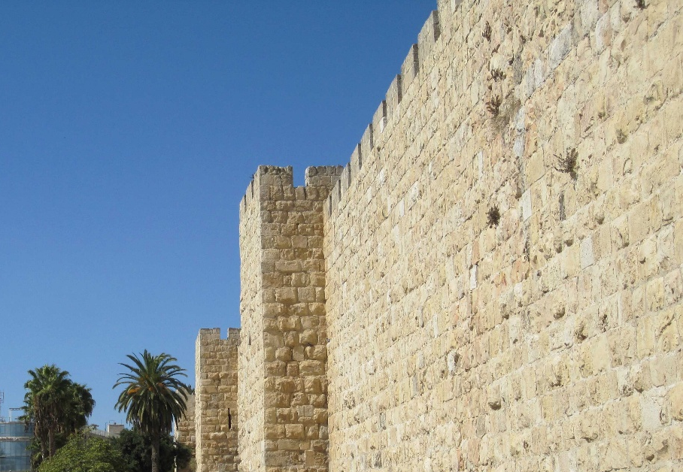

Chapter 6 - How we come to God

King Solomon reigned over Israel for forty years. He became famous for the wisdom God had given him and for his great wealth. While he was king, the priests and Levites carried out their duties at the Temple. The daily offerings were made and the three great Feasts were kept each year.
When anyone entered the Temple court, they would see the large altar that stood between the entrance to the court and the Temple building. Here, the people learned how sinful people could come to a holy God. The punishment for sin is death, as God had warned Adam, the first man who God created (Genesis 2: 16-17). What God says, never changes, and so we read in the New Testament, ‘The wages of sin is death’ (Romans 6: 23). However, this verse tells us that God gives the gift of eternal life to those who trust in His Son, the Lord Jesus Christ.
Jesus died to take the punishment for everyone who trusts in Him for forgiveness of their sin. We read in the Old Testament how God taught His people to come to Him. An animal, such as a lamb or a bullock, must die instead of the sinner. Of course, no animal can take away sin, but as the people offered their sacrifices, they were looking forward to the Saviour, God had promised to send.
Our sin is like a high wall, separating us from God, because God is holy: perfectly pure and good. Sin must be forgiven before we can know God as our Father and our Friend. Every morning and evening the priest offered a lamb on the altar. This would have taught the Israelites that they needed cleansing from sin, every day. The death of the Lord Jesus on the cross put an end to animal sacrifices. The death of the perfect Son of God was sufficient to bring forgiveness to every boy or girl, man or woman, who trusts in Him.
Israel had seven special times during the year, called Feasts. God told Moses what should happen on the Feast days. There were three of the Feasts when the Israelites were to come to Jerusalem: the Feast of the Passover, the Feast of Pentecost and the Feast of Tabernacles.
At the Passover time, the people remembered how God had rescued them from slavery in Egypt. At that time, a lamb had died for each family. The New Testament tells us that the Lord Jesus is our Passover, who gave his life for us (1 Corinthians 5: 7). The Feast of Pentecost was a time of thanksgiving for the early harvest. We learn from the New Testament that on the day of Pentecost God gave His Holy Spirit to the apostles and others who were with them. On that day, three thousand people became Christians (Acts 2: 41).
The Feast of Tabernacles was a time to remember when the Israelites had lived in tents in the wilderness for forty years. We can give thanks to God for His help when we have had difficult times in our lives.

Find outs:
- To disobey God, is sin. What was the warning that God gave to Adam? (Genesis 2: 16-17).
- What is God’s gift to all who trust in the Lord Jesus? (Romans 6: 23).
- What were the sacrifices in the Temple a picture of? (Hebrews 9: 28).

Chapter 7 - Israel Divided

It is sad to read that, after such a wonderful start to his reign, Solomon disobeyed God in a very serious way. God had warned His people that they must not marry people from other nations who worshipped idols. Like kings in other countries at that time, Solomon had many wives. His wives came from many countries and they brought their idol-worship into the land of Israel. Solomon even built places for his wives to worship their idols.
God spoke to Solomon about his disobedience. He told him that when his son was king, only the tribe of Judah in the south of Israel, would remain loyal to the kings who came from the family of King David.
Solomon’s son, Rehoboam, made a very foolish decision early in his reign. He spoke very roughly to the people, telling them that he would make their lives much harder than his father had done. Just as God had said, all the tribes except Judah rebelled and had their own king, whose name was Jeroboam. From that time onwards, the land of Israel was divided. The northern part was called Israel and the southern part was called Judah. The Levites living in the north of Israel did move to Judah, so that they could continue their work at the Temple.
King Jeroboam had a problem. He thought that if people travelled to the Temple at Jerusalem for the Feast days, they would be sorry about their rebellion and join with Judah once again. He decided to make places for worship in his kingdom, so that he could tell the people they need not make the journey to Jerusalem. He chose two cities, Dan in the north and Bethel in the south of his kingdom. In each place he set up an idol: a calf made of gold. He chose some people to be priests to offer sacrifices to the idols. He also made a special feast day.
God had chosen the people of Israel to show other nations how good it was to worship the true God and have His blessing. Instead of doing this, the northern kingdom of Israel had become idolatrous just like the nations around it.
Jeroboam became known as the king ‘who made Israel to sin’. None of the kings who came after him in the north of Israel loved and obeyed God. Even in Judah there were some kings who brought idol worship into the land. However, there were a number of kings who loved God, and who led the people back to the true worship. We will learn how the Temple was affected by some of the kings who reigned in Judah in the next chapter.

Find Outs:
- What do the first two commandments teach? (Exodus 20: 3-6).
- What does the Bible say that idols cannot do? (Psalm 115: 4-7).
- Why did God say that the people of Israel should not marry people from other nations? (Deuteronomy 7: 3-4).

Chapter 8 - Bad days and good days at the Temple

After the death of King Solomon, what happened at the Temple depended very much on the kings that followed him. In this chapter, we will learn about just how different some of the kings of Judah were from each other.
Ahaz became king more than two hundred years after Solomon. He set up idols in the land and offered sacrifices to them. God did not help King Ahaz and he was defeated in battle by the king of Syria and the king of Israel. Instead of realising that he was in trouble because he had disobeyed God, Ahaz decided he would bow down to the gods of Syria. He destroyed some of the contents of the Temple and shut the Temple doors. The priests and Levites were unable to do their work. No offerings were made to God: no sacrifices for the sin of the people, asking God’s forgiveness.
The son of Ahaz who became the next king, was Hezekiah. How different he was from his father. He understood all the harm his father had done to the land of Judah. In the very first month of his reign, he opened the Temple doors and set the priests and Levites to work putting things right. Sacrifices were offered and thank offerings given. The Levites sang praise to God and the people of Judah rejoiced.
King Hezekiah sent messengers to the people of Judah and Israel, calling them to come to Jerusalem to keep the Passover Feast. In Israel, people laughed at the messengers, but there were some who did travel to Jerusalem.
Many people gathered at the Temple. The Levites sang praise to God and the priests offered sacrifices to God. It was a time of great rejoicing, such as had not happened in Jerusalem since the time of King Solomon. The Feast continued for fourteen days instead of seven, because it brought much joy to the people.
After Hezekiah died, his son Manasseh became king. He was very different from his father and brought idol-worship back into Judah. Manasseh even placed an idol in the Temple, where the true God only, was to be worshipped. He also placed altars to sacrifice to his idols, in the Temple court. Manasseh would not listen to God’s warnings and so the king of Assyria’s army took him away to Babylon. There he prayed to God and God forgave him and he was able to return to Jerusalem. He showed that he was truly sorry for his sin, by taking the idol and the altars out of the Temple. He made sure the priests made the offerings and he also told the people of Judah to serve the true God.
Manasseh’s son Amon did the evil things that his father had done but he did not repent of his sin. However, when his son Josiah became king, there was a great change. Josiah was only eight years old when he became king and while he was a teenager, he showed that he loved God. When he was twenty years old, he began to destroy the idols and altars in Judah and in Israel as well. After this he set men to work in the Temple as Hezekiah had done. It had to be done again after the harm done by idolatry while Amon and Manasseh reigned.
While the work in the Temple was going on, Hilkiah the priest found a book. This was God’s law, given in the time of Moses. When the words of God’s law were read to Josiah, he was very distressed. He realised how disobedient to God the nation had been. God sent a message to Josiah, that trouble would come because of the people’s sin, but this would not be while he was king.
King Josiah made sure that the offerings were made and that the Passover Feast was kept once again.

Find outs:
- How long had Hezekiah been king when he began putting things right in the Temple? (2 Chronicles 29: 3-5).
- Where did Manasseh place one of his idols? (2 Chronicles 33: 7).
- How do we know that Manasseh was genuinely sorry for his sin? (2 Chronicles 33: 15-16).
- What did Hilkiah the priest find in the Temple? (2 Chronicles 34: 14).

Chapter 9 - Warnings ignored.

We might wonder why the people of Judah turned away many times from the God who had been so good to them. There was always the temptation to be like the nations around them. There was also the fact that idol-worshippers could forget about the law God had given.
God’s rules for how we should live, are good. They teach us to love the God who gave us life, and to treat other people as we would like to be treated. God taught His people to be kind to those who were poor, to children who had no father and to people who were blind or deaf, or had other difficulties.
God would not protect His people while they were bowing down to idols and disobeying Him. He would not defend them against their enemies so that they could say that it was their idols who helped them.
God was patient and sent prophets such as Isaiah and Jeremiah, to warn the people of Judah of coming disaster, if they continued to rebel against Him. He offered free forgiveness if they repented – were truly sorry for their sin and changed their ways (Isaiah 1: 16-20). Jeremiah spent many years warning the people that they would be taken away from the land God had given them, because of their sinful ways. No-one wanted to hear what Jeremiah said. There were false prophets who told the people what they liked to hear: ‘everything will be alright. After all, we have the wonderful Temple. No need to listen to Jeremiah’.
Jeremiah was very sad. He knew that the messages he gave to the people, were from God. Even after Josiah’s good reign, there were kings of Judah who went back to idolatry. At last King Nebuchadnezzar army took many of the people as captives to Babylon. They also took the precious things from the Temple to Babylon. The Temple was burned and the walls of Jerusalem were broken down.
How tragic it would be if this was the end of the story of the Special House. This was not to be the case. Among all the messages from God that Jeremiah gave to the people of Judah, there was a promise. God said that the captivity in Babylon would last for seventy years. After that, people would be allowed to return to their own land (Jeremiah 29: 10). At that time, there would be a new chapter in the story of the Special House.
During the seventy years of Judah’s captivity the Babylonian Empire lost its power, and the next great world power was the Persian Empire. The Jews (as the people of Judah became known) continued to live away from their own land until seventy years were completed, as God had said.

Find Outs:
- What did God say that His people should stop doing (Isaiah 1: 16) and what did He say they should do? (Isaiah 1: 17).
- What sort of things did the false prophets say? (Jeremiah 23: 17) and what did God say about them? (Jeremiah 23: 21-22).
- What promise did God give to His people who were to be taken captive? (Jeremiah 29: 10).

Chapter 10 - Rebuilding

In the very first year of his reign, Cyrus, King of Persia made an announcement. He said that God had told him to build Him a house at Jerusalem. Any of the Jews who were willing, were free to go back to their own land and rebuild their Temple. The king also gave the Jews all the precious things that Nebuchadnezzar had taken from the Temple at Jerusalem.
The leader of the Jews, was a man named Zerubbabel, who came from the family of King David. He led about fifty thousand people on the journey back to Judah. Travelling must have been difficult, carrying enough food, finding places to rest at night. Even when the returned exiles arrived in Judah, life was not going to be easy. People who had been living in their land would be sure to make things difficult for them.
For six months, the Jews were busy sorting out their houses. Families needed homes to settle down in and this must have been quite difficult too. Once this was done, the people gathered at Jerusalem. It was the seventh month, when the Feast of Tabernacles was held. Joshua the High Priest and Zerubbabel the leaders of the people, with their helpers, built an altar. This meant that the morning and evening sacrifices could be offered and the Feast could be kept.
In the second year back in Judah, the Jews laid the foundation of the Temple. There was great rejoicing when the foundation was complete. The Levites played their instruments and sang praise to God. All the people who were there joined in praising and thanking God because their Temple would be built again. However, among all the rejoicing, there was some sadness. There was the sound of weeping. Older men who remembered the first Temple, had tears in their eyes as they thought of their beautiful Temple being destroyed. They would have known that if the people of Judah had obeyed God, He would have protected them from their enemies.
After the joy of seeing the Temple foundations laid, trouble came. Letters were sent to the king who came after Cyrus, complaining about the Jews. The complaint was, that if the city of Jerusalem was rebuilt, the Jews would no longer pay their taxes to the king of Persia. King Artaxerxes believed what he was told and commanded that the rebuilding must stop.
For some time, there was no progress on the Temple building. Then God sent two prophets, Haggai and Zechariah, to encourage the builders to restart the work. This time local people asked the Jews, who had told them that they could build the Temple. The Jews explained how King Cyrus had told them to do it and also had given them the gold and silver that King Nebuchadnezzar had taken.
The king of Persia at this time was Darius and he ordered a search to be made, to find out if what the Jews said was true. A scroll was found which proved all that the Jews had said about King Cyrus. King Darius then gave orders that the Temple must be built. He also said that money and things that were needed, must be given to the Jews so that they could complete the building.
Once again, there was a time of great joy in Jerusalem. When all the work of building was finished, the priests and Levites could do their work again. Daily sacrifices could be offered and the Feast of Passover was kept.

Find Outs:
- Why did King Cyrus say that the Temple must be built? (Ezra 1: 2).
- What was the first thing to be built? (Ezra 3: 2).
- What was the result of King Darius having a search made, to see if the Jews were telling the truth? (Ezra 6: 8-10).

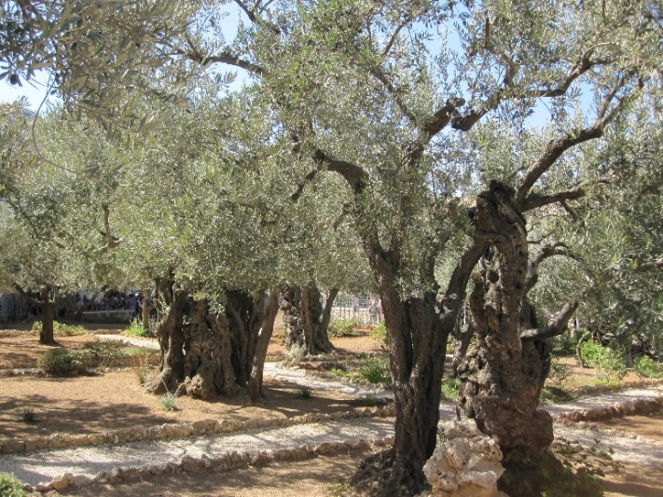

Chapter 11 - Troubled years

Almost a hundred years after the second temple was built, the prophet Malachi was given a message from God for the people of Judah. The Book of Malachi, the last book in the Old Testament, tells us a lot about life in Judah at that time.
The priests and Levites were busy at the Temple. They offered the sacrifices and carried out their other duties, but God saw that something was wrong. There was no love for the God who had been so good to them. There was no reverence (respect) for the God who is so great. The priests were not teaching the people about how they should live and so the people were not living in a way that pleased God.
After this rather sad picture of how the Temple was being used, there were about four hundred years, when God did not send any more prophets to His people. The Jews remained in their own land while many changes took place in the world. The Persian empire was conquered by Alexander the Great and so the Greek empire became the great power. For quite a long time, all went well for the Jews. The High Priest was allowed to look after the Jewish affairs.
A great change came when the Greek king Antiochus made sacrifices on the Temple altar, worshipping Zeus (a false god) where only the true God should have been worshipped. A very brave man named Judas led some of the Jews against all that the king was doing. Antiochus did not think he needed to send a very large army against the Jews. Amazingly, the soldiers he did send were defeated. Judas reached Jerusalem, and he cleansed the Temple, so that the priests and Levites could once again do all that God had taught them to do. The Jewish people still celebrate Judas’ victory and cleansing of the Temple, with the Feast of Hanukkah in December each year (The Feast of Lights).
Judas’ victory did not bring any lasting peace in Judah. The Jews were affected by power struggles that went on around them. Roman power began to grow and about sixty years before Jesus was born in Bethlehem, Jerusalem came under Roman control.
King Herod, known as Herod the Great, was made King of Judea (as Judah was now known). King Herod was not Jewish, but he tried to please the Jews so that they would accept him. He began to enlarge the Temple, making it a more magnificent building. This work actually took forty-six years to complete. In spite of this, King Herod could be very cruel at times. The Romans also used Roman Governors to make sure the law was kept.

Find Outs:
- Malachi says that the people were not coming to God with r _ _ _ _ _ _ _ _ (Malachi 1: 6).
- Who should have taught God’s law to the people? (Malachi 2: 7).
- Who does Malachi say will suddenly came to the Temple? (Malachi 3: 1).
- How long did it take to make the Temple larger and more magnificent? (John 2: 20).
Chapter 12 - Two visits to the Temple

The work of making the Temple larger had been going on for about twenty years, when a Baby boy was brought to the Temple by His mother Mary and her husband Joseph. The Baby boy was about six weeks old when He was brought to the Temple, as God had taught His people. Mary and Joseph were amazed when a man named Simeon took the Baby in his arms. Simeon had a promise from God that he would see the promised Saviour, before he died. He gave thanks to God that he had seen the Saviour.
The Baby Boy in the Temple that day, was Jesus, the Son of God. He had been born in Bethlehem as the prophet Micah had said, about seven hundred years before (Micah 5: 2). God’s Holy Spirit had prompted Simeon to go into the Temple that day, and also to realise that the promised Saviour had been born. An old lady, named Anna, was also there and she gave thanks to God when she saw the Baby Jesus. She then spoke about Him to the people in Jerusalem, who she knew were waiting for the Saviour to come.
We read about Jesus visiting the Temple again when He was twelve years old (Luke 2: 41-49). It was Passover time, and Mary and Joseph took Jesus with them to Jerusalem. They travelled with other people who lived in Nazareth as they did. The journey was about eighty miles and would have taken several days.
On the way back to Nazareth, after the first day’s travel, Mary and Joseph could not find Jesus. They had not been anxious about Him, because they were with friends and relatives and expected Him to be with people He knew well. Not finding Him with any of their friends, they became very concerned and made their way back to Jerusalem and searched for Him: where could He be? At last they found Him. He was in the Temple, talking with the teachers who were there. Even at twelve years old, those who heard Jesus speak that day, were amazed at His understanding. When Mary told Him how anxious they had been, His reply was that He must be about His Father’s business.
The Bible tells us about just these two visits to the Temple when Jesus was a child, but He would probably have made other visits at the time of Passover or the other Feasts. The Bible does tell us of the many times He came to the Temple as an adult. Do you remember how some of the older people were sad, when they thought about the splendour of the first Temple? God gave a promise that the second Temple that the returned exiles built, would have more glory than the first Temple (Haggai 2: 9). It was the coming of the Son of God that would be the glory of the second Temple.

Find Outs:
- Name two people who understood that the Baby who was brought to the Temple, was the Saviour God had promised to send (Luke 2: 25-28 and 36-38).
- Where did Mary and Joseph find Jesus and why did He say He was there? (Luke 2: 46 and 49).
- What was promised about the second Temple? (Haggai 2: 9).

Chapter 13 - The Son of God in the House of God

The New Testament does not tell us anything about the life of Jesus from when He was twelve years old until He was thirty. Once He was thirty years old, He spent three years travelling around the land of Israel: Judea in the south, Galilee and Samaria in the north. He taught the people about God in a way that the priests and teachers had failed to do. He also did many miracles, healing the sick, the disabled, the blind and the deaf, whenever they were brought to Him. The miracles He did showed clearly that He was the Son of God, the Saviour God had promised to send.
Sometimes Jesus went into the courts of the Temple, to teach the people who had gathered there. There were also two visits to the Temple that He made, one in the first year of His ministry and the other in the third year. These two visits tell us a great deal about how the Temple was being used at that time.
It was the time of the Feast of the Passover. Jesus looked around the Temple court. There were men there selling animals for people to offer as sacrifices. There were also moneychangers there, because Jews came from near and far at the time of the Feast, and some needed to change their coins for Jewish ones. Instead of a place of teaching and prayer, the Temple court looked like a marketplace. The Lord Jesus drove the men and the animals out of the Temple, overturning the tables they had set up. In the third year of His ministry during the week before He was crucified, Passover time was again very near. He saw the Temple court as He had seen it before, taken over by sellers of animals and moneychangers. The time of the Feast was a good time for making money, but once again, Jesus drove them out. This time He used some words from two of the Old Testament prophets, Isaiah and Jeremiah, “… My house shall be called a house of prayer, but you have made it a den of thieves.” (Isaiah 56: 7 and Jeremiah 7: 11).
It seemed that nothing had been learned since the time of the prophet Malachi. The priests still went into the Temple building to carry out their duties, but there was no loving reverence for God, in the hearts of those who should have been an example to the people. They should never have allowed the area around the Temple to be used as a place of trading and even of cheating people.
One day, when the disciples pointed to the beautiful Temple buildings, Jesus told them that a time was coming when that Temple would be completely destroyed. This did happen in the year AD 70, nearly forty years after Jesus had spoken of it. Roman soldiers set fire to the Temple and it was burnt to the ground. God had not protected His house which was being used in such a wrong way, by people who had rejected His beloved Son.

Find Outs:
- What did Jesus call the Temple? (John 2: 16).
- What did the prophet Isaiah call the Temple? (Isaiah 56: 7).
- What did Jesus say would happen to the beautiful Temple building? (Matthew 24: 2).

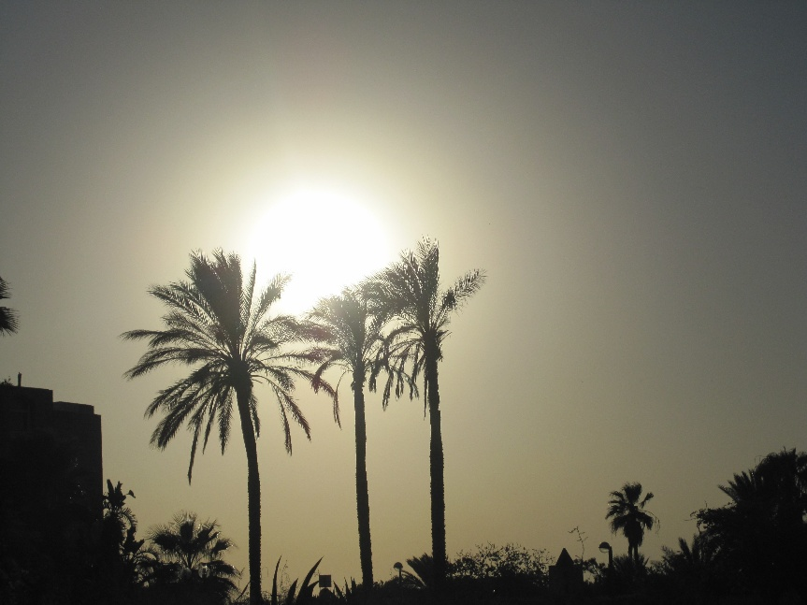

Chapter 14 - A Change in the Temple

The priests and leaders of the people, hated the Lord Jesus. They did not like to see the crowds of people who followed Him, gladly listening to His words. They plotted to have Jesus put to death. They told the Roman governor that Jesus was claiming to be a king and they persuaded him that he should condemn Jesus to death.
At the time that Jesus died on the cross, a strange and wonderful thing happened in the Temple. The large curtain (called ‘the veil of the Temple’) between the two rooms, the Holy Place and the Most Holy Place, was torn from the top to the bottom. Only God could have done this. No-one had ever been allowed to enter the Most Holy Place, except for the High Priest, on one day each year. In the Tabernacle and in Solomon’s Temple, the Ark of God stood in the Most Holy Place. This was the sign of God’s presence with His people. It is not known what happened to the Ark when Nebuchadnezzar invaded Jerusalem. It seems that it was not in the second Temple. We do not know whether anything was put in its place in the Most Holy Place.
Any priest who was in the Holy Place when the curtain was torn, would probably have been very frightened. The priests knew that they must not even look beyond the curtain. They would have wondered what this sudden tearing of the curtain could mean.
We can know what it meant, because the Bible explains it to us. In Old Testament times, the people were taught how sinful people could come to a God who is holy: perfectly pure and good. All that was done at the Tabernacle and then at the Temple, was like a picture of what the Lord Jesus would do.
Jesus said, “I am the way…” (John 14: 6). He is the way into God’s presence for everyone who trusts in Him. When He died on the cross, the Temple curtain was torn, because God accepted the perfect sacrifice of His Son. There was no more need for animals to be sacrificed. The Lord Jesus died to take the punishment for the sins of everyone who trusts in Him for forgiveness. There was no more need for a High Priest to enter the Most Holy Place once a year. When our sins are forgiven, we can know God’s presence with us and speak to Him at any time. Of course, our God is a great God, and we speak to Him with both love and reverence (respect).

Find Outs:
- What happened in the Temple when Jesus took His last breath? (Mark 15: 37-38).
- What did Jesus say about Himself? (John 14: 6).
- How did the Jews persuade Pilate, the Roman governor, to condemn Jesus to death? (John 19: 12). (‘Caesar’ was the title of the Roman Emperor.)
Chapter 15 - A Story without end

It would be very sad indeed, if this story ended with a ruined building in Jerusalem. The Bible does not leave it there. After the Lord Jesus rose from the dead and went back to heaven, the men who had been His disciples began the task of telling people about Him. As Jesus had told them, this began in Jerusalem, then continued through the land of Israel and then to other countries (Acts 1:8).
In the Book of Acts, the disciples of Jesus are called ‘apostles’, a word that means someone sent to do a particular work. Peter the disciple, the follower and learner of Jesus, became Peter the apostle, given by God the task of teaching others. In the New Testament we have two letters that Peter wrote to Christians who were in many countries. In his first letter, he calls Christians ‘living stones’ being built into a ‘spiritual house’ (1 Peter 2: 5). This may sound difficult to understand, but is easier when we remember that in the New Testament, the word ‘church’ means people, not a building.
Jesus said that He would build His church (Matthew 16: 18) and His church is made up of men and women, and boys and girls who trust in Him. It is wonderful to know, that if we belong to the Lord Jesus, we are part of the church He is building. This building is made up of people from many countries who lived at different times. We do not see this building now but one day it will be complete. That will be when our lives in this world are over, and if we are trusting in the Lord Jesus now, we will be with Him in heaven. The Book of Revelation describes many, many people from every land and language, praising God in heaven (Revelation 7: 9-10).
God will not allow sin, that has caused such trouble on earth, to spoil His heaven (Revelation 21: 27). Heaven is for forgiven sinners. Anyone who is too proud to confess their sin and seek forgiveness, will bear the punishment their sin deserves. This will be in a place the Bible calls hell, separated from God and from everything that is good.
In heaven there will no longer be need for a Special House that teaches people how to come to God. God Himself will be with His people and all who love Him will enjoy His wonderful presence always.

Find Outs:
- Revelation 22: 17 is an invitation. Find the two words in the last sentence that say who is invited.
- Find the prayer in Revelation 22: 20 that has just five words.
- The apostle John was given a vision of a wonderful city. What did he not see in the city? (Revelation 21: 22).

FURTHER INFORMATION

For further information, or to get in touch, please use the contact form on—
www.oneagleswings.me.uk

Online E-books by the same Author
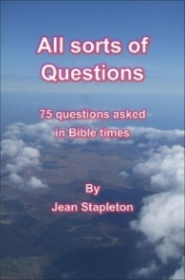
(10-13yrs) (11-13 yrs) (9-12yrs)
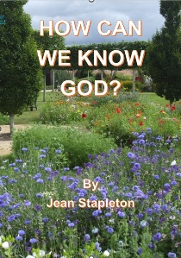
(9-12yrs) (11-14yrs) (9-12yrs)

To Download these books, go to –

https://www.oneagleswings.me.uk/ebooks/

(10-13yrs)

