Paul’s Missionary Journeys

Map of the Eastern Mediterranean taken from ‘Nelson’s Complete Book of Bible Maps and Charts’ copyright 1996, 1993 byThomas Nelson, Inc., with additional place names superimposed in Blue.
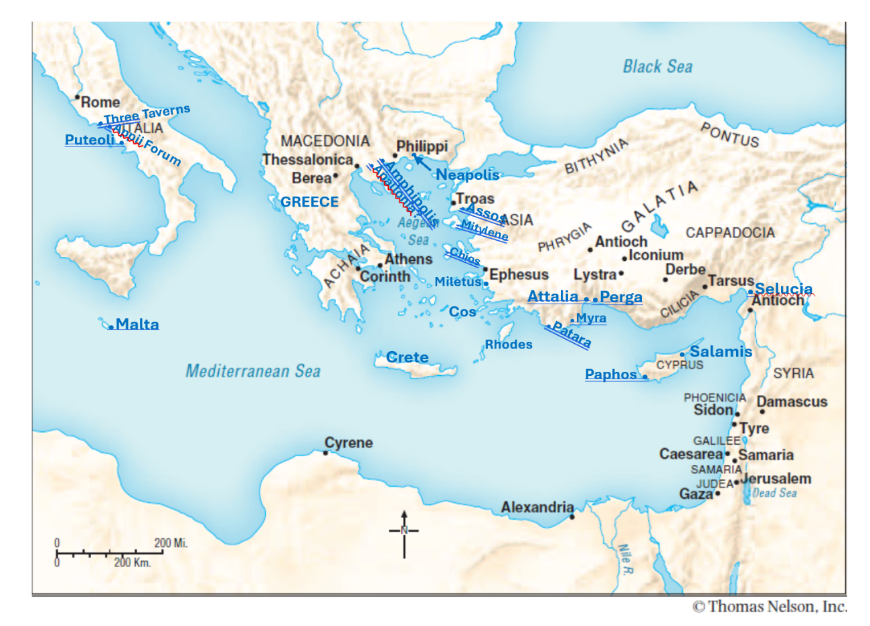

Note to the Reader: Nelson’s Complete Book of Bible Maps and Charts, Third Edition is intended for nonprofit, non-commercial use in classrooms and seminars. Photocopies made for such settings should be limited to 1,000 units and cannot be sold or used for any profitable enterprise. Questions about usage should be directed to Thomas Nelson.

